Word Count: 1000

Student ID: 1472703

Tutor: Marzieh Farahani

Client Side Web DevelopmentAssignment 2

Contents

Introduction 5

Testing BecomeGreen Website 6

Index.html 6

Staff.html 7

Stock.html 8

Course.html 9

Contact.html 10

Validation 11

HTML 11

Index 11

Staff 12

Stock 14

Course 16

Contact 19

CSS 21

Index 21

Staff 22

Stock 23

Course 24

Contact 25

Accessibility 26

Index 26

Staff 29

Stock 32

Course 35

Contact 39

Functionality Testing 41

Form 41

Course 41

Contact 41

Social Media 42

Index, staff, stock and course 42

Contact 42

Twitter 42

Facebook 43

YouTube 44

index 44

Reflection 45

Conclusion 47

Bibliography 48

Appendix A - Design Document 49

Appendix B – Codes 56

Appendix C – File Structure 69

# Introduction

This report consists of all testing and validation of my BecomeGreen website project. It will also include my reflection showing my thoughts on the project, changes that were made and what improvements could be made in future. It will also conclude everything that has been finished in this project. The purpose of this project is to successfully create a functioning website.

URL: <http://jamesg2703.ccacolchester.com/BecomeGreen/>

# Testing BecomeGreen Website

## Index.html

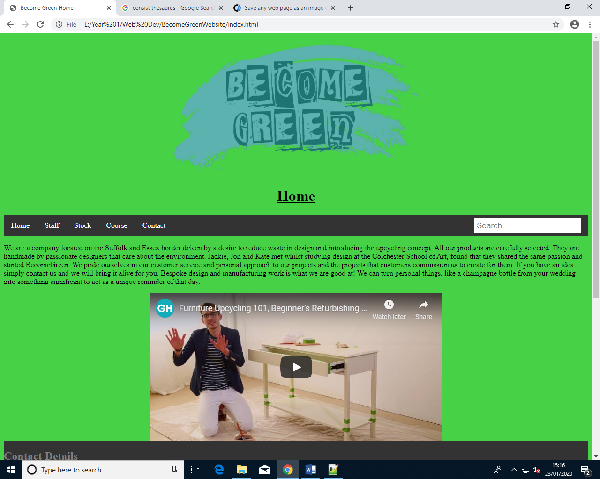

## Staff.html

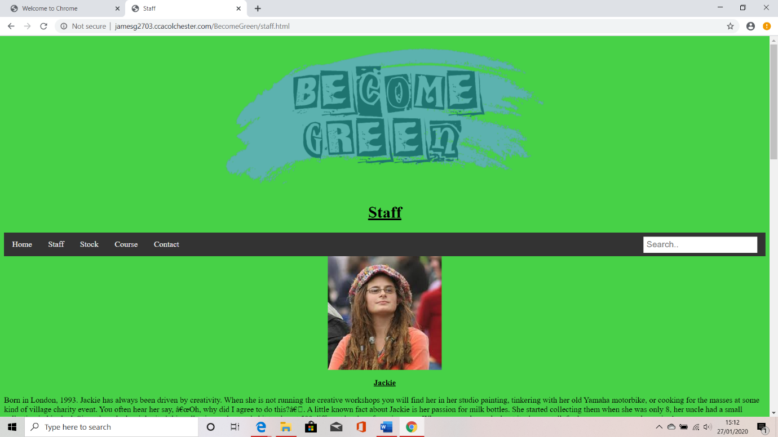

## Stock.html

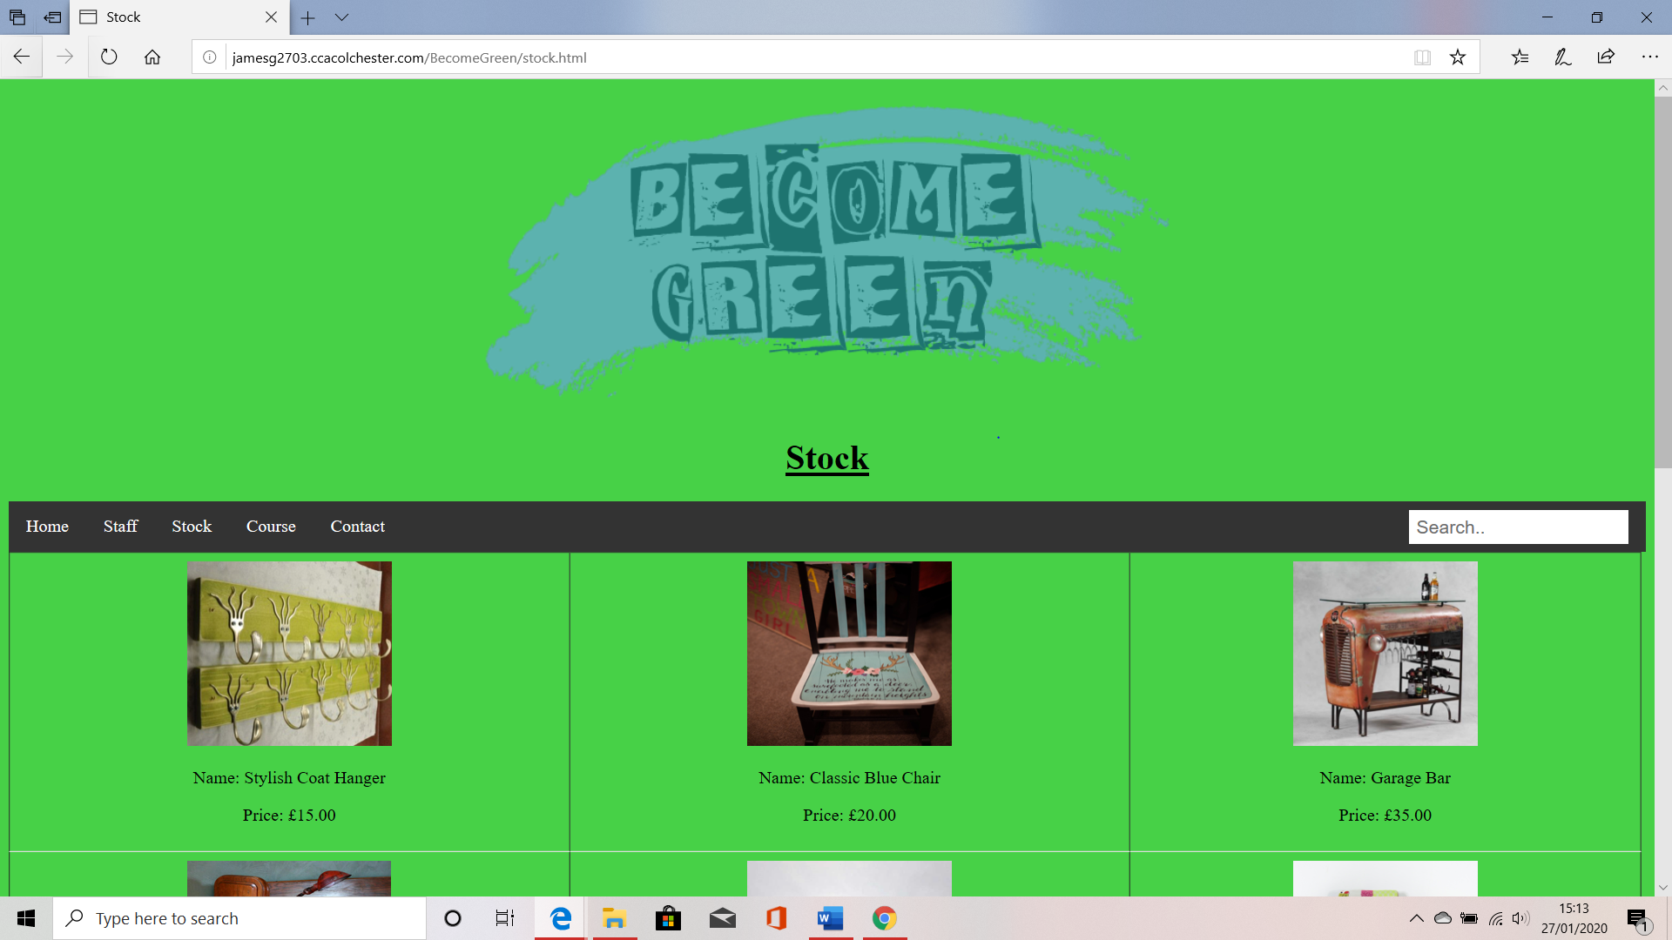

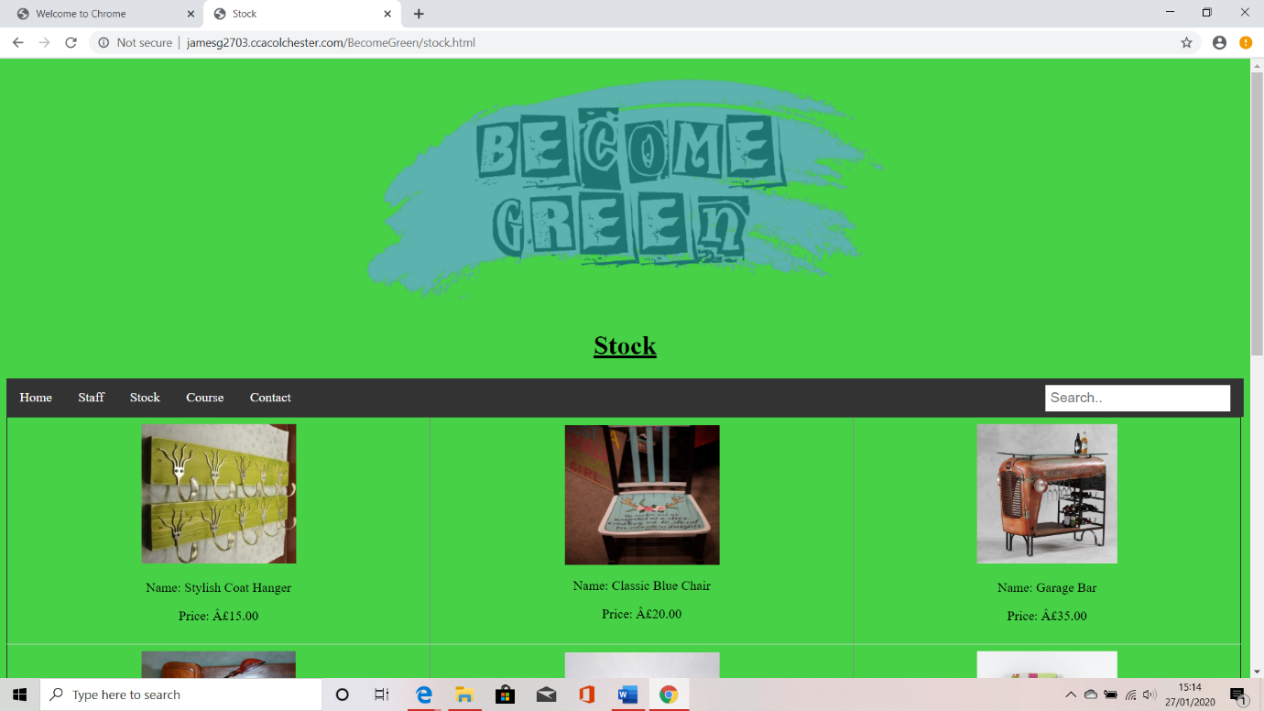

## Course.html

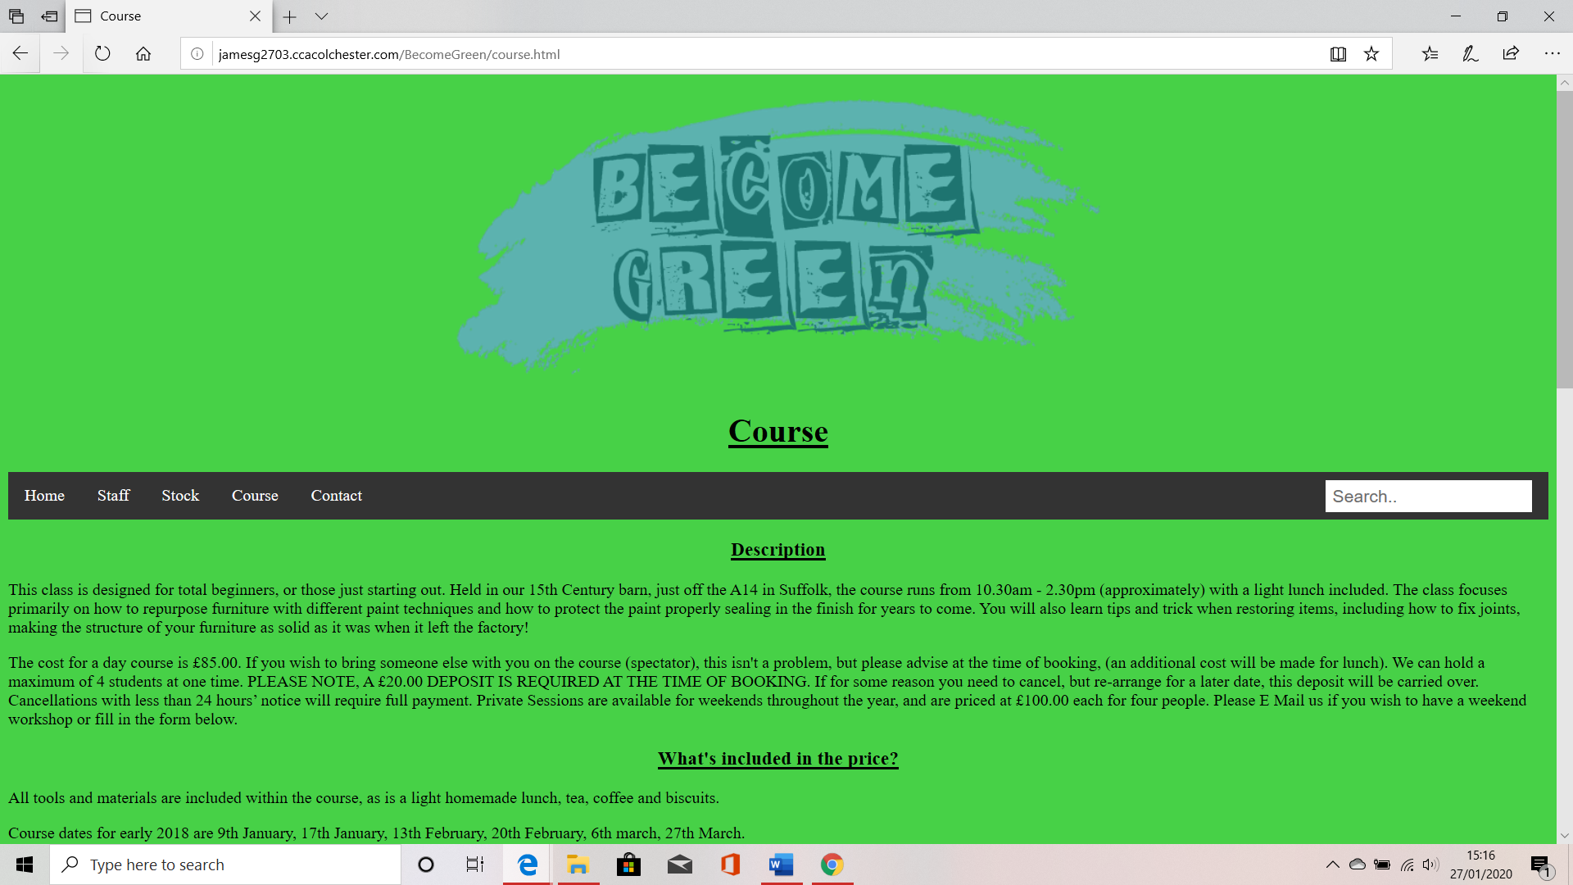

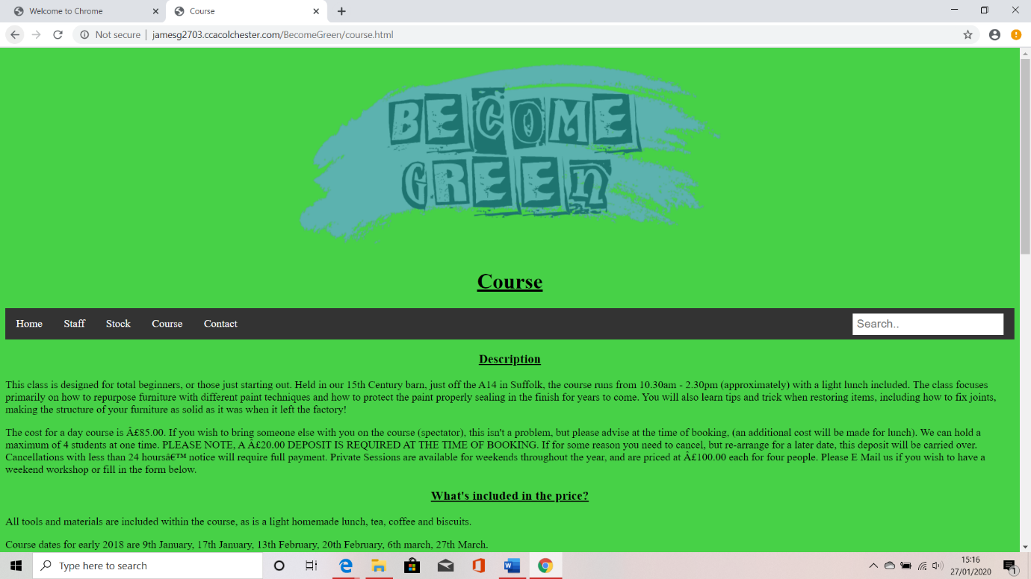

## Contact.html

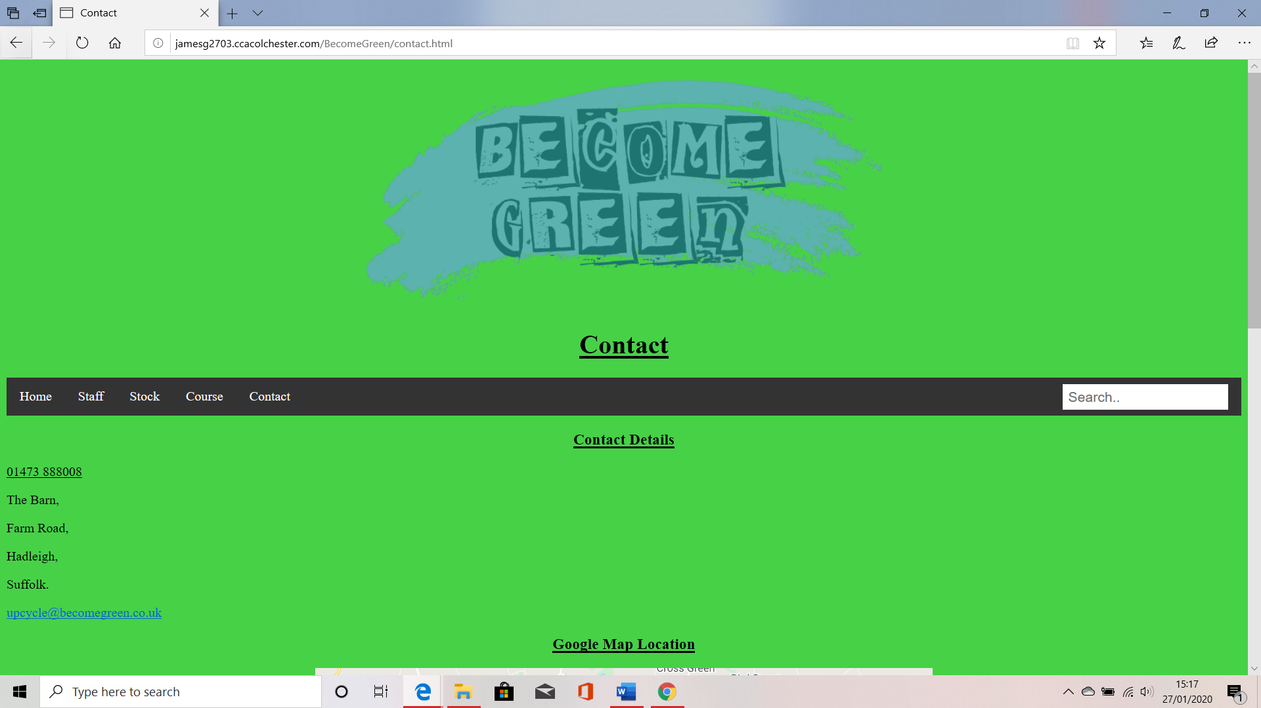

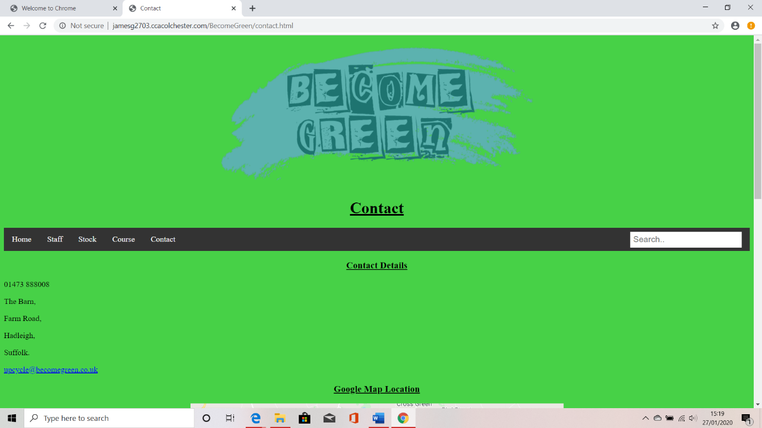

# Validation

## HTML

### Index

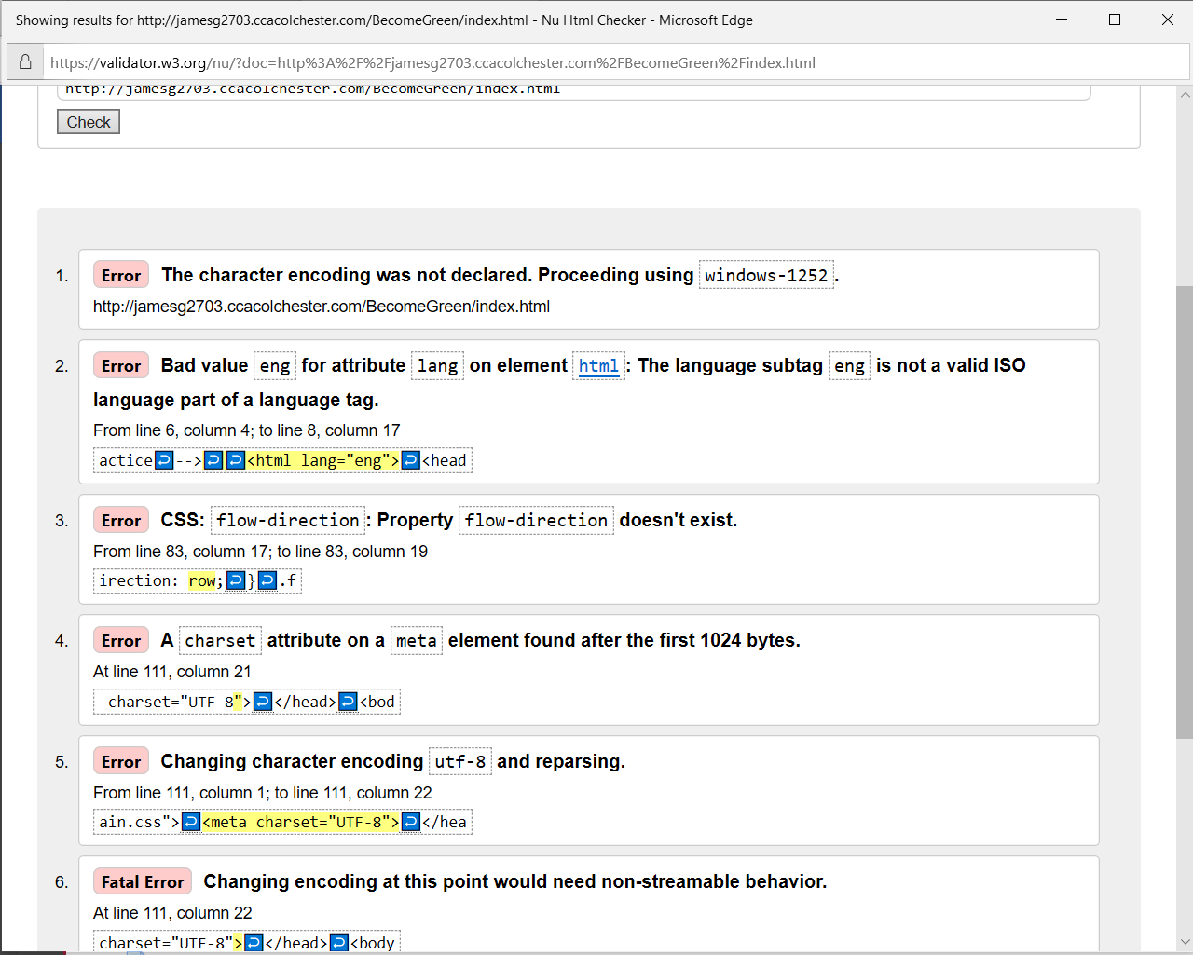

### Staff

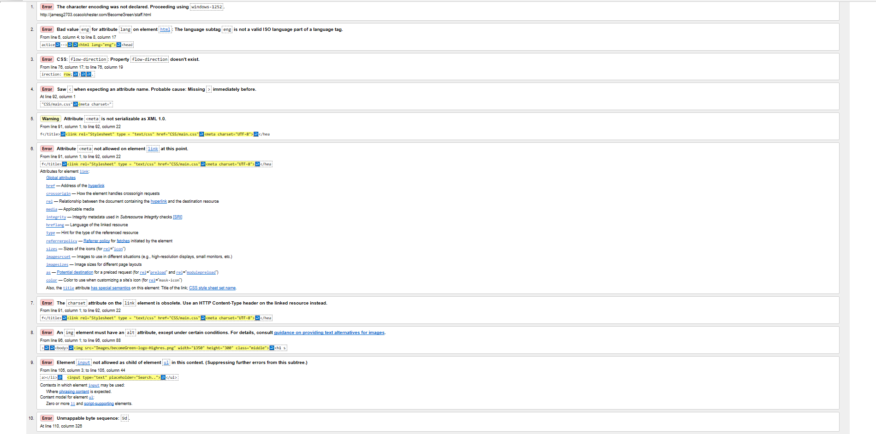

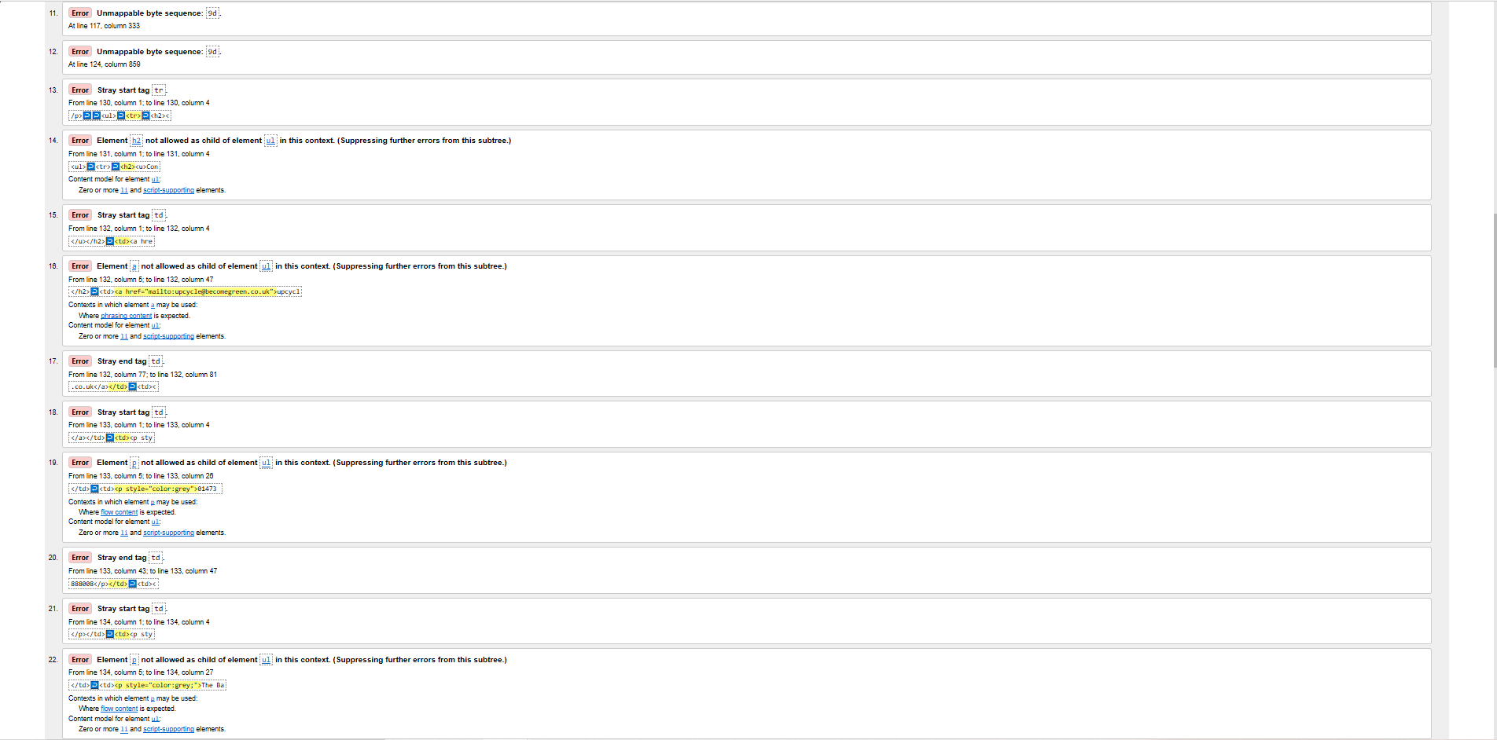

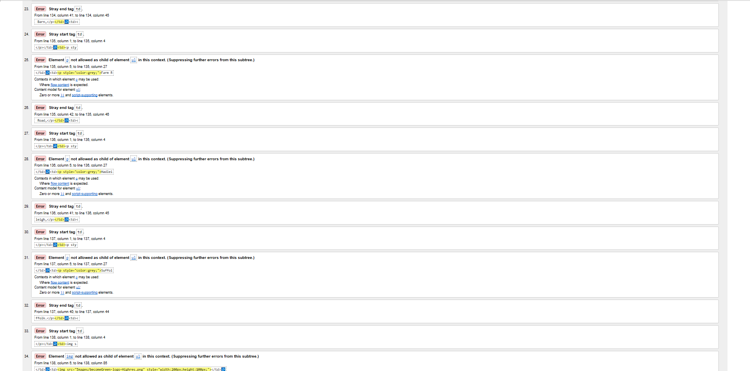

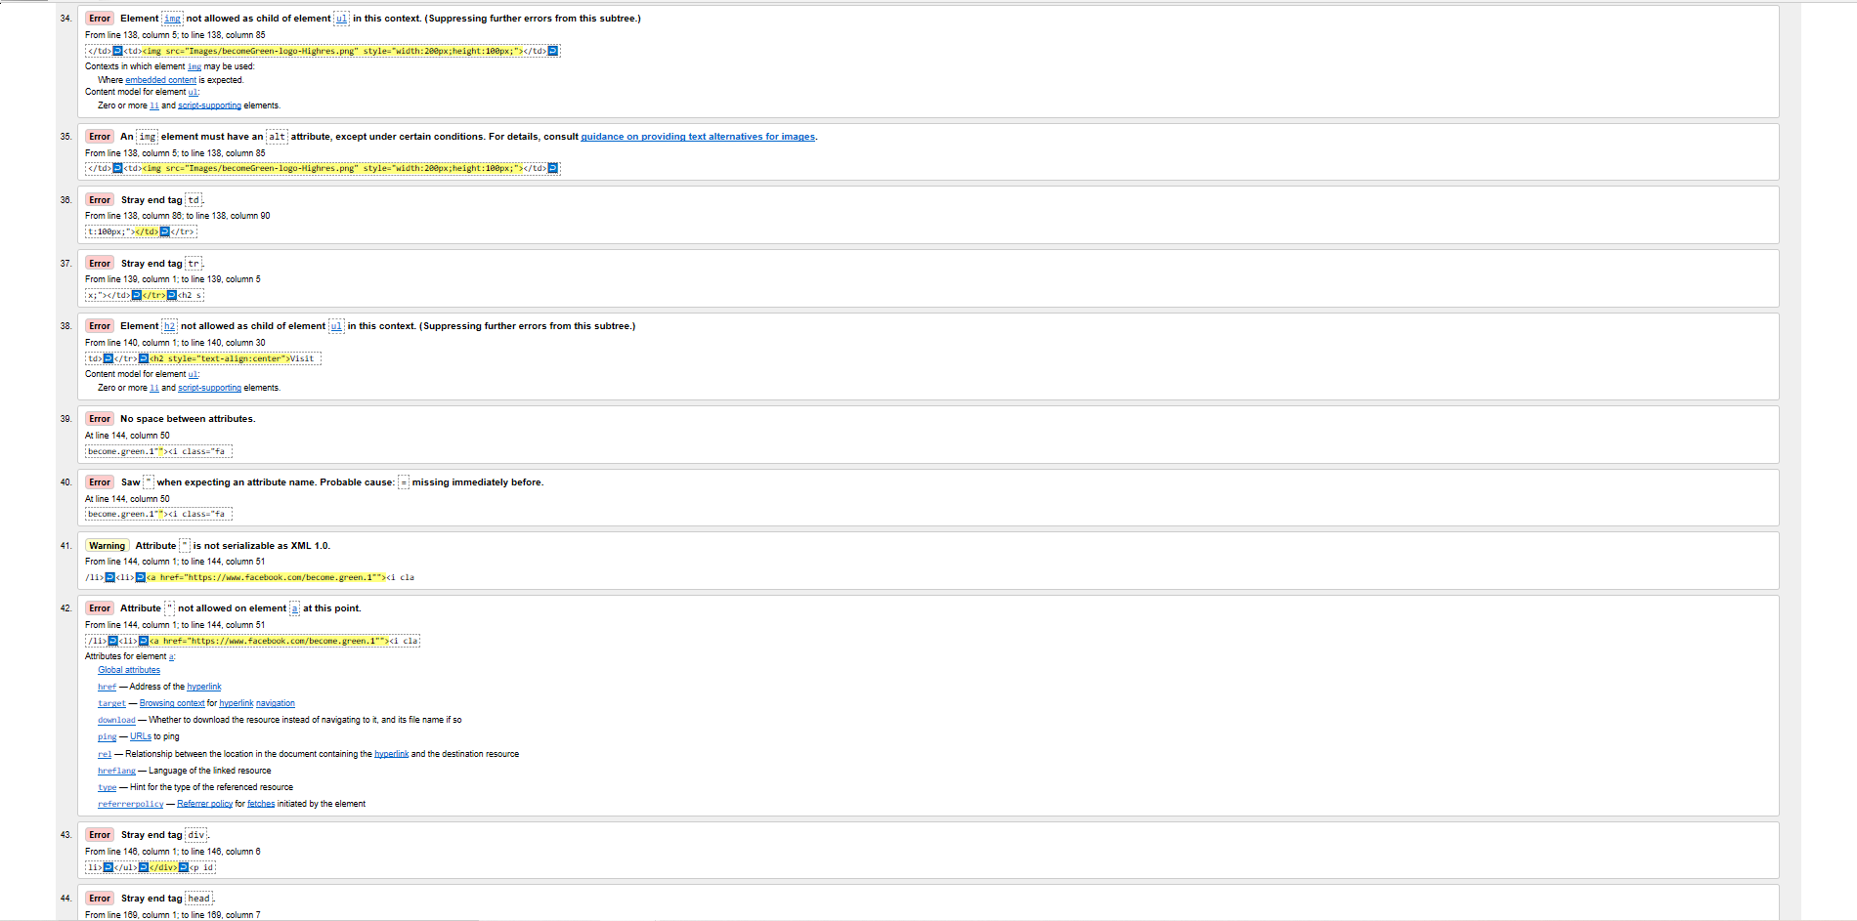



### Stock

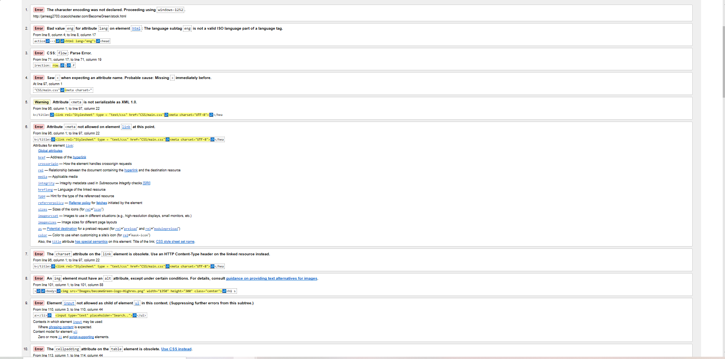

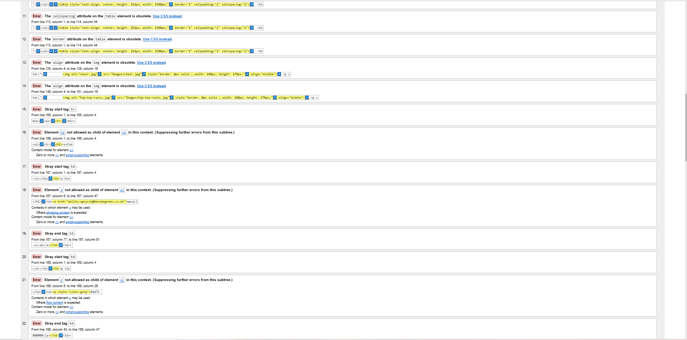

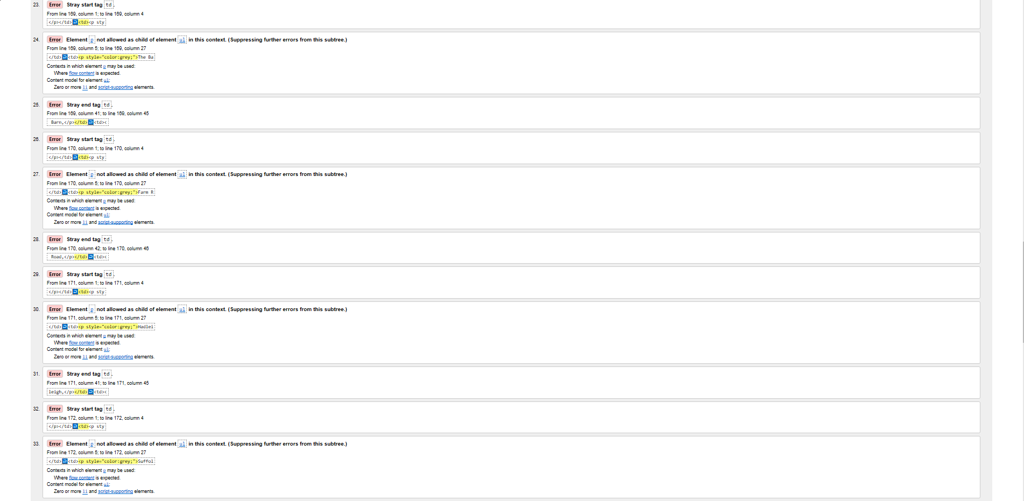

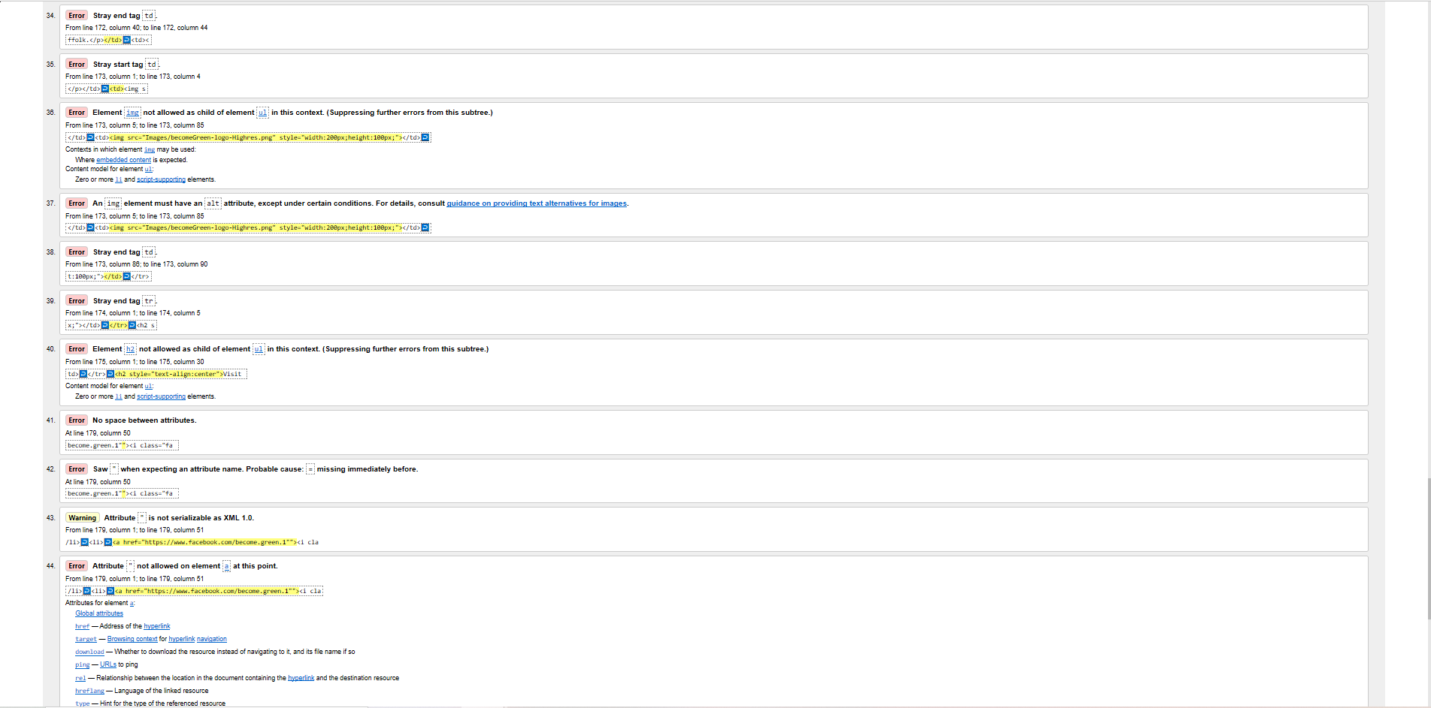

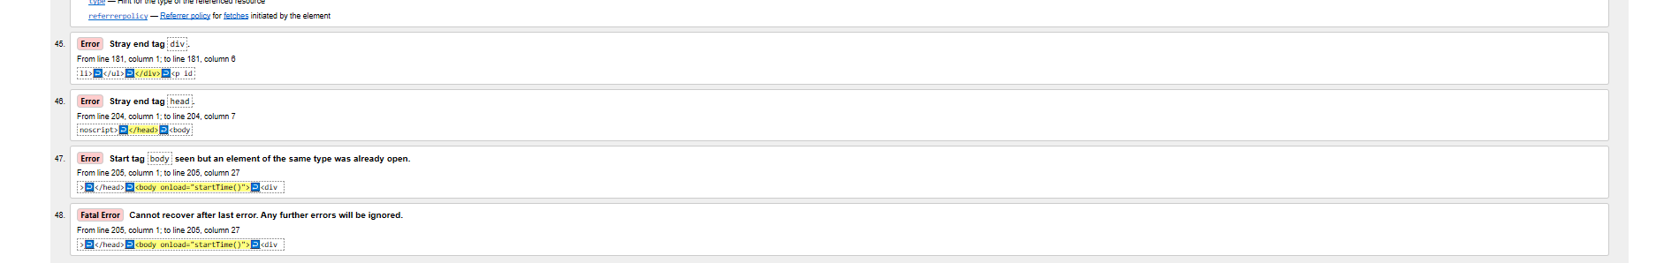

### Course

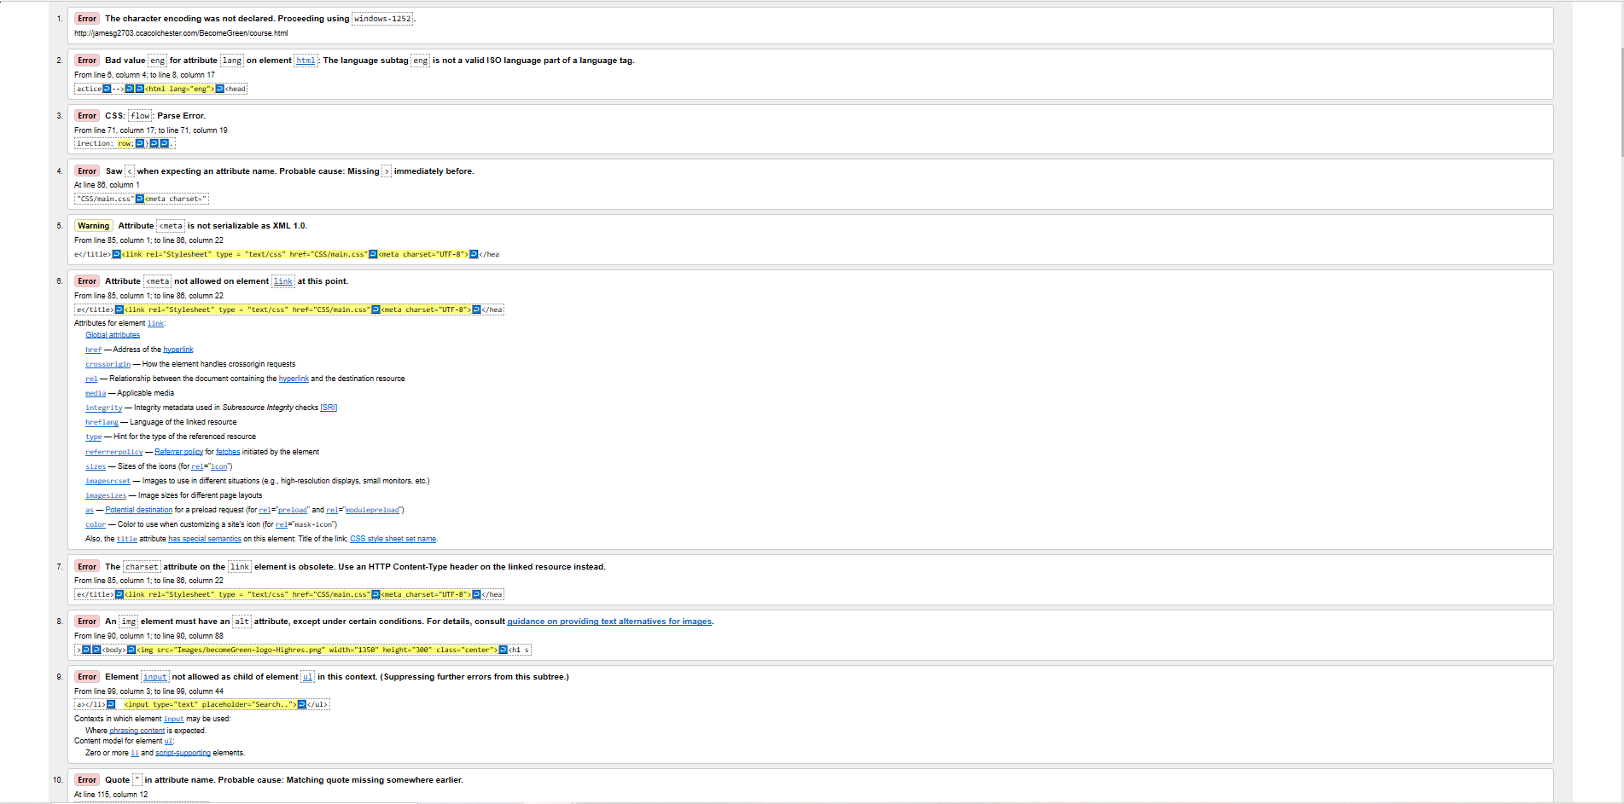

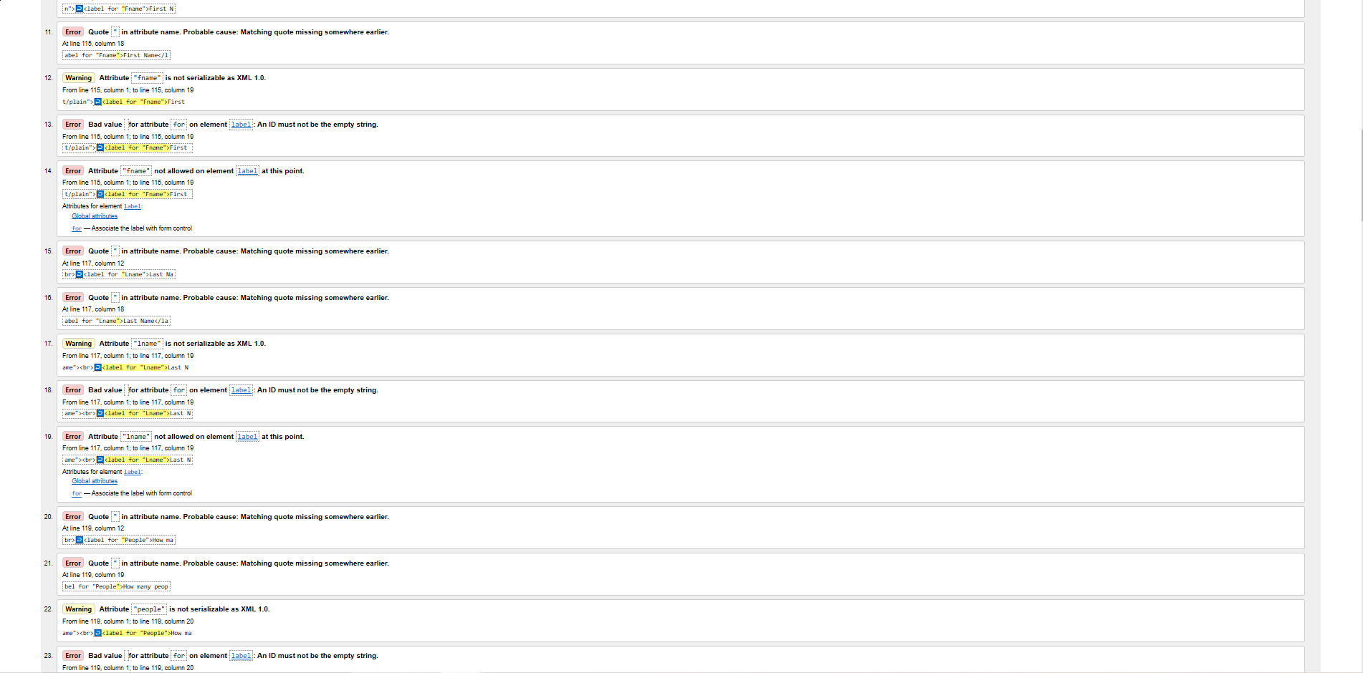

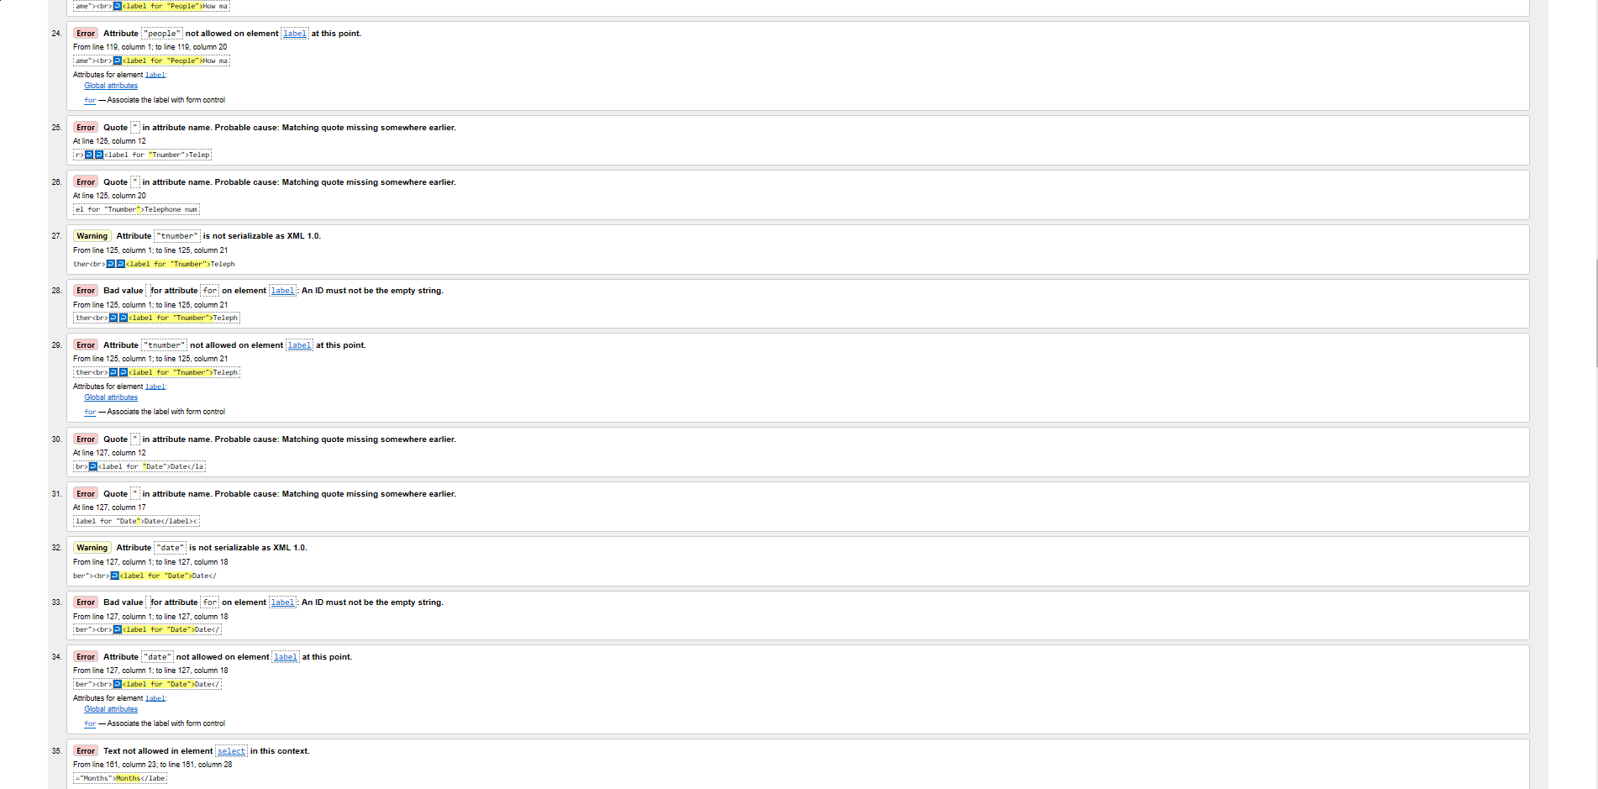

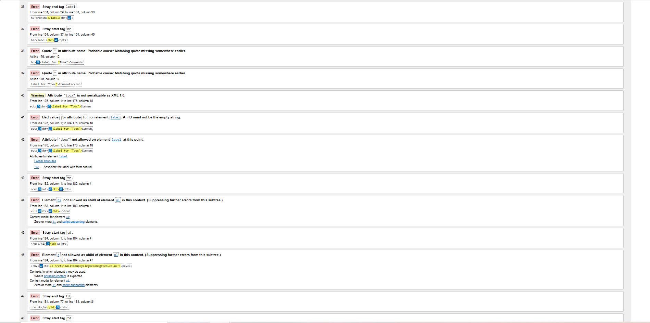

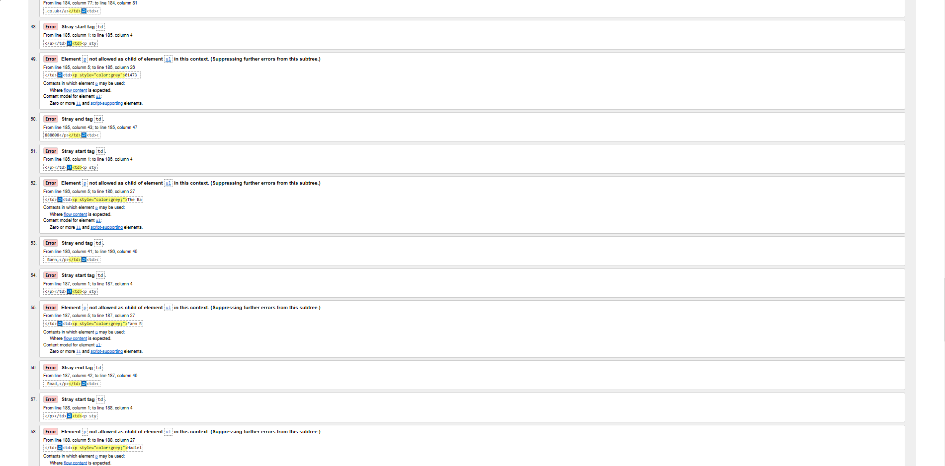

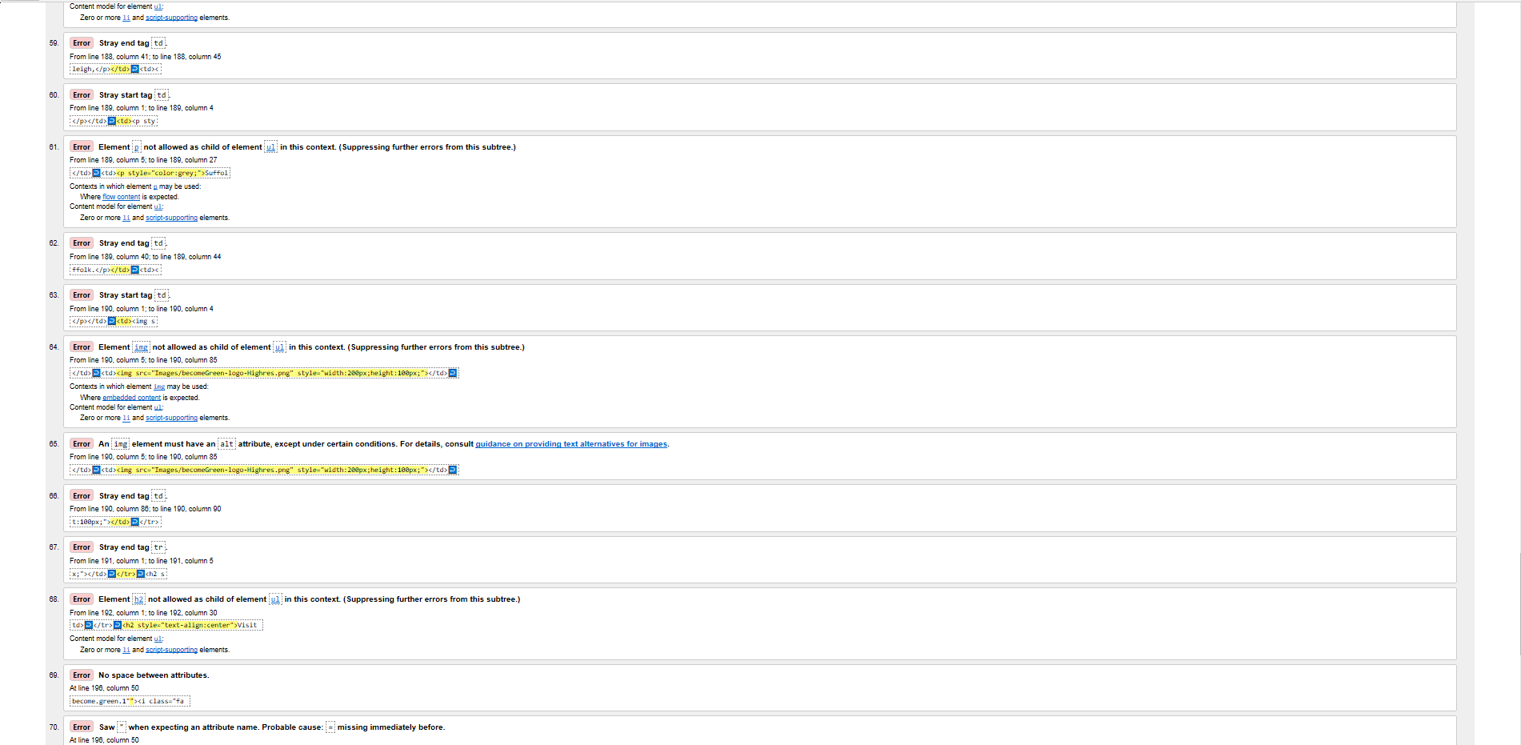

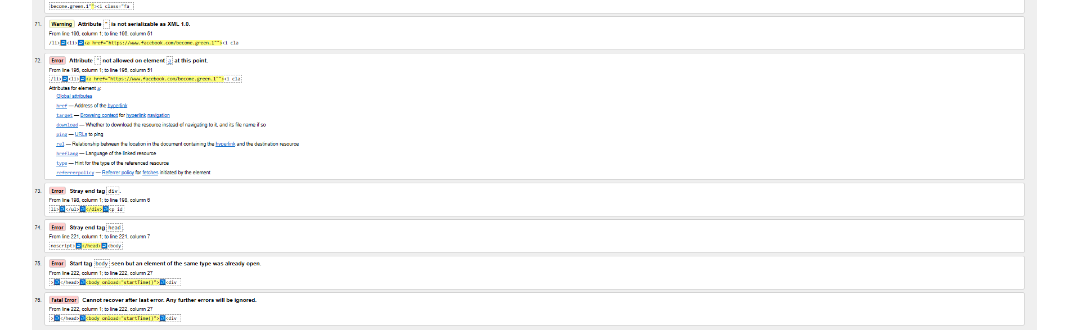

### Contact

## CSS

### Index

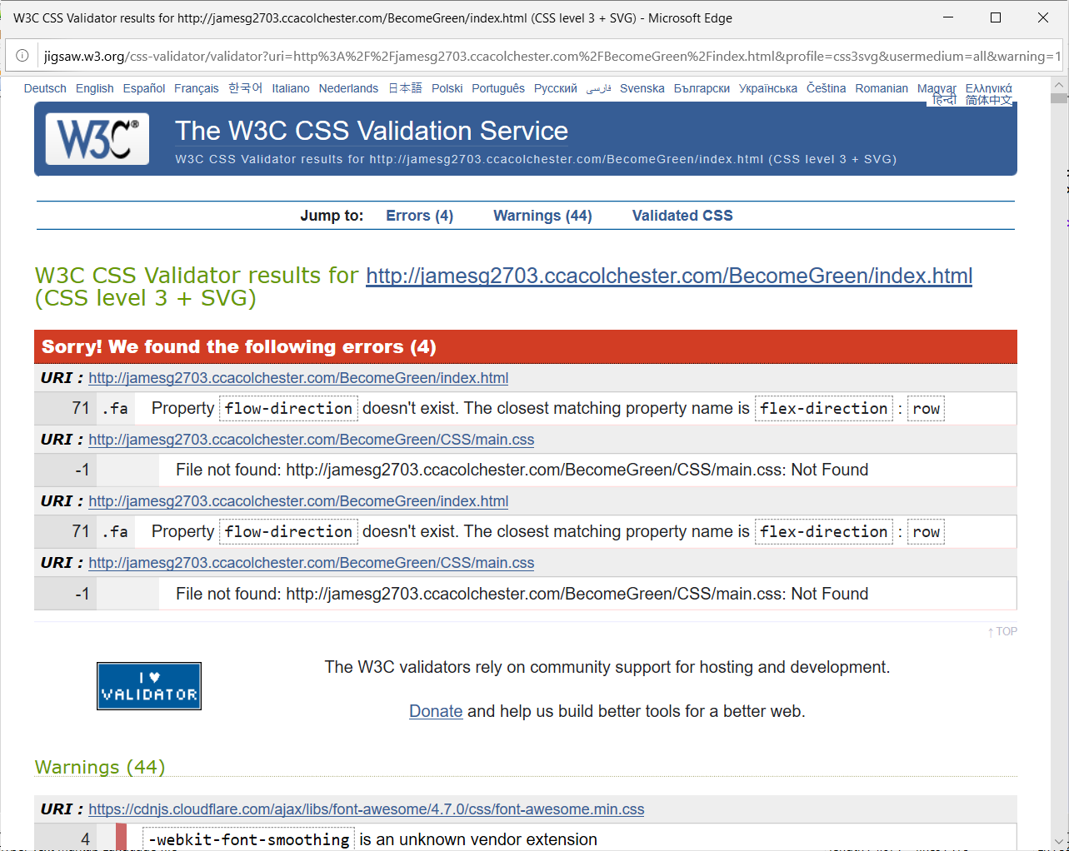

### Staff

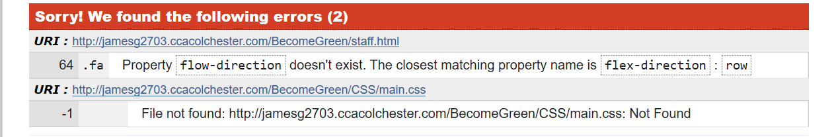

### Stock

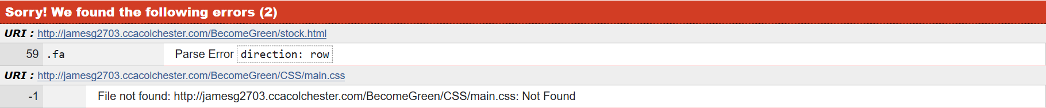

### Course

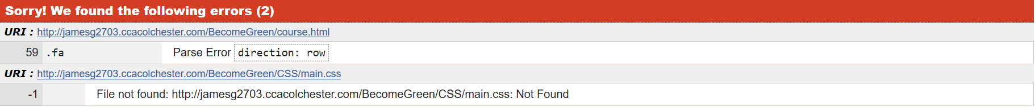

### Contact



## Accessibility

### Index

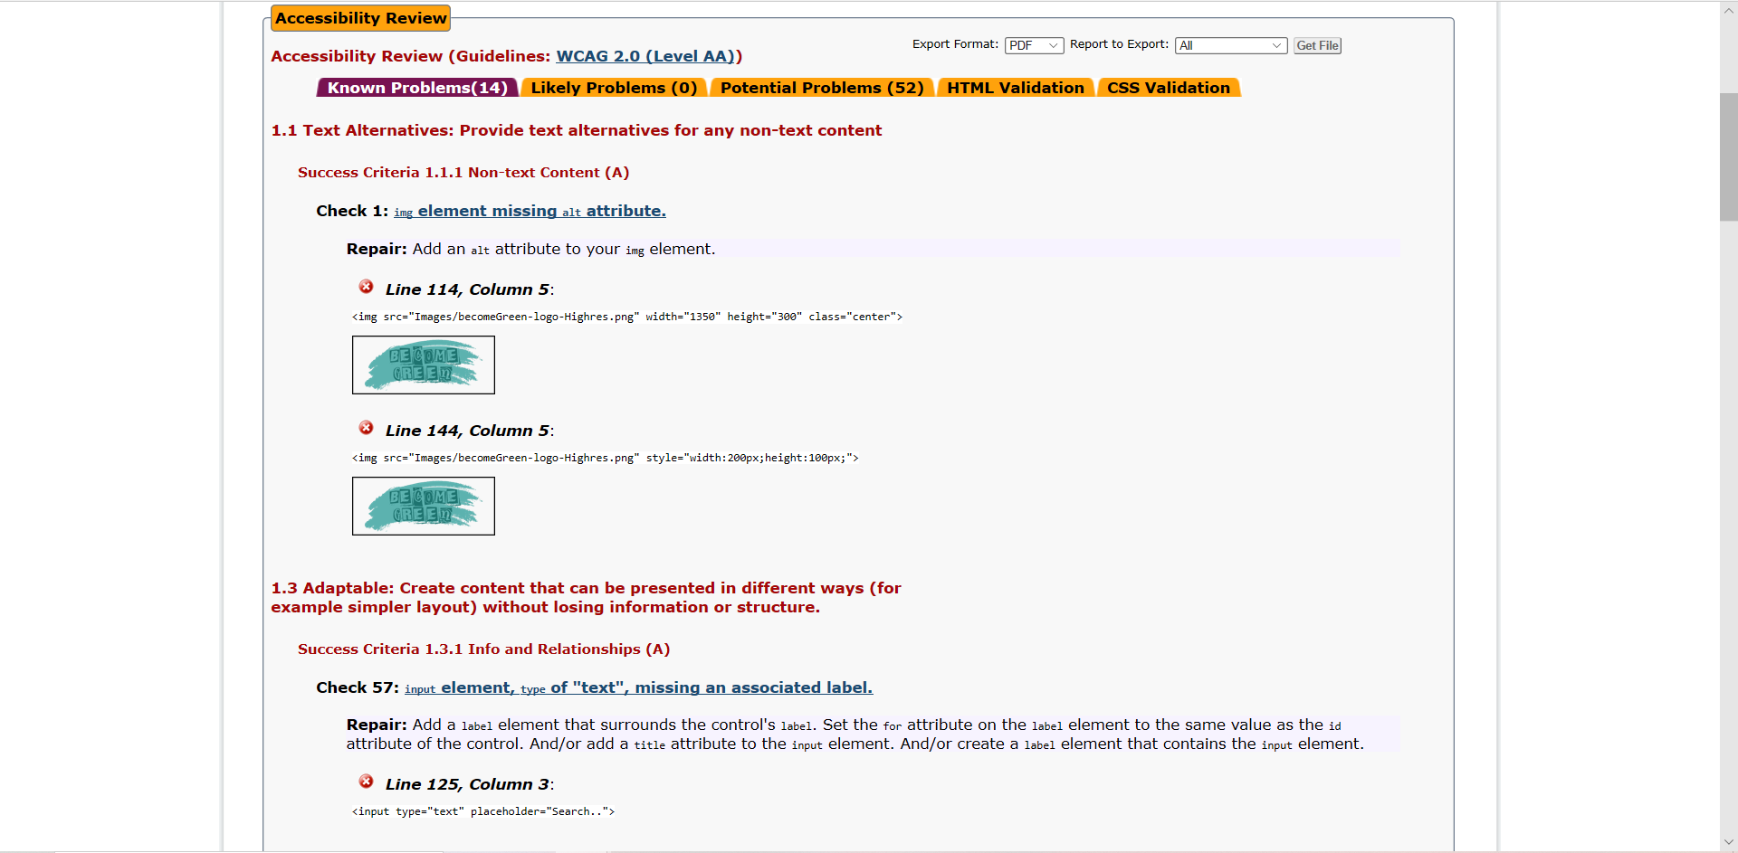

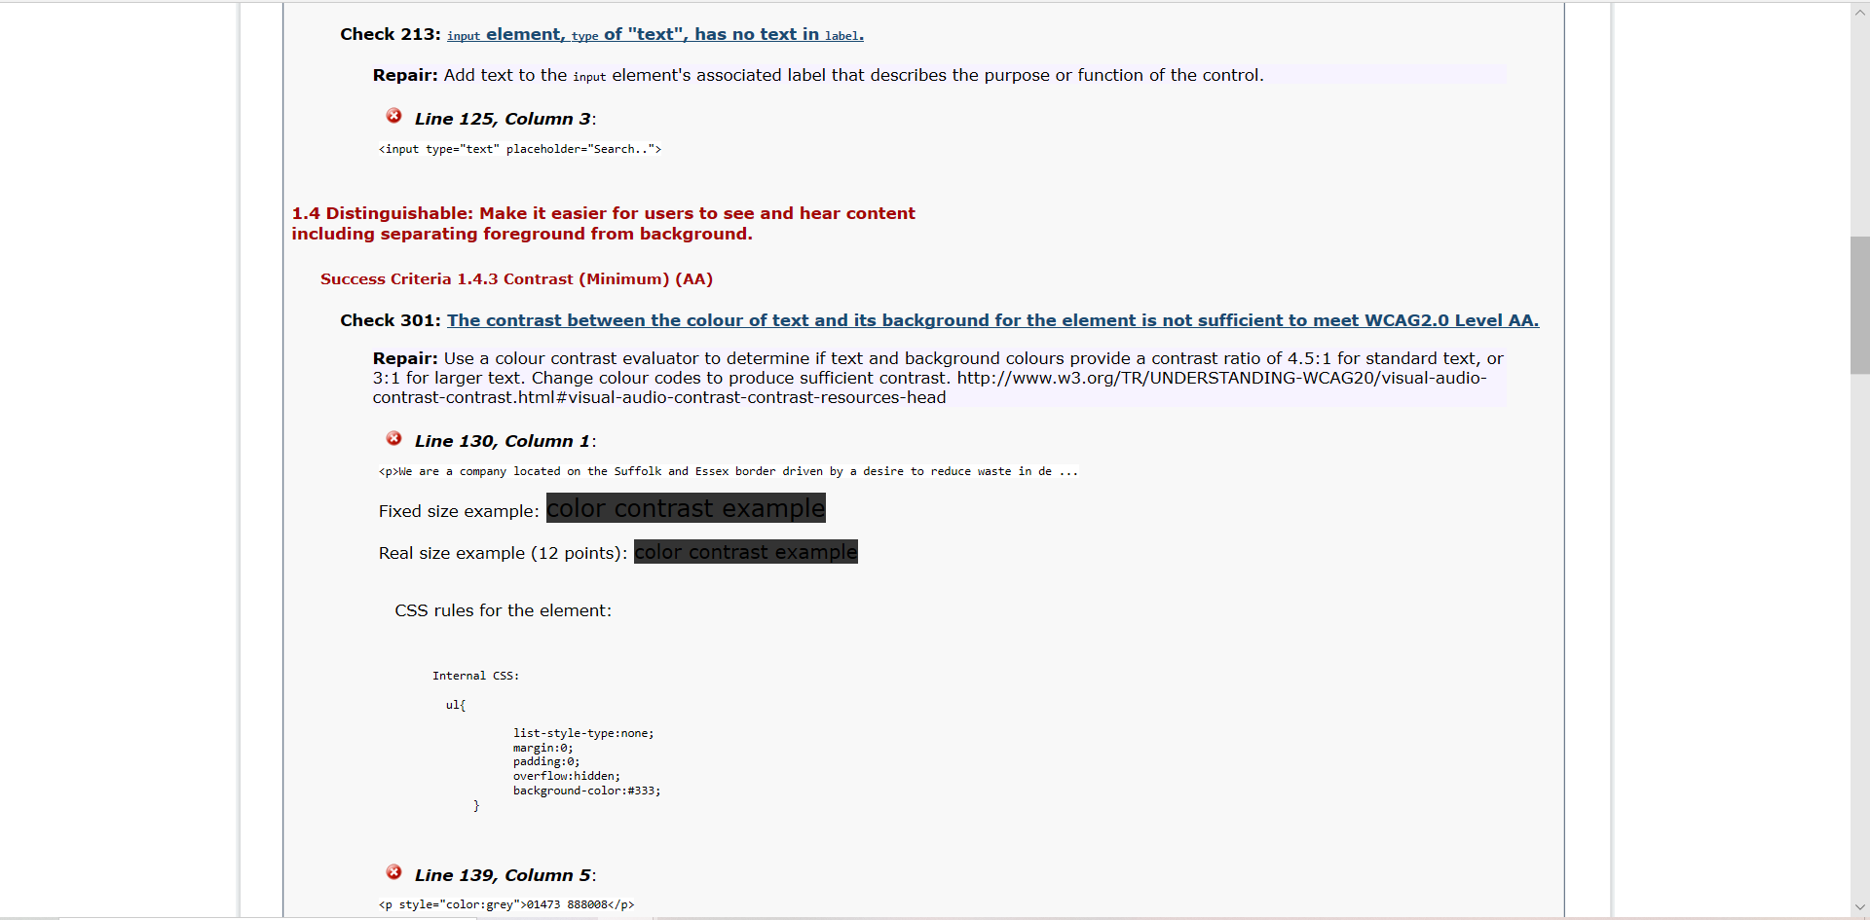

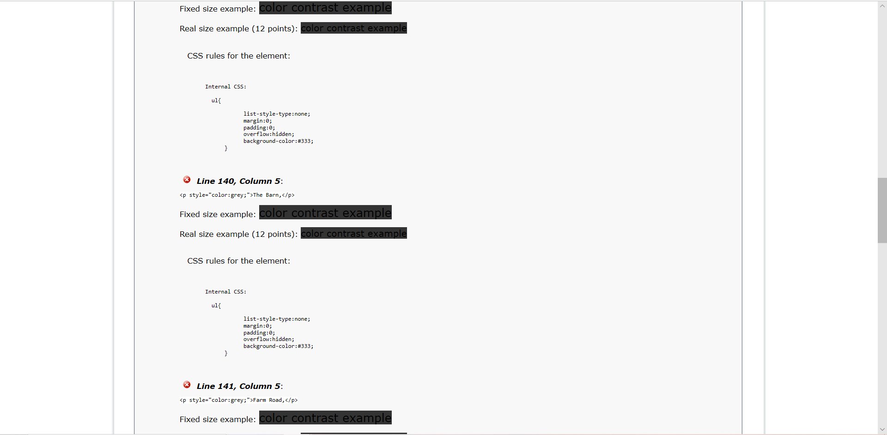

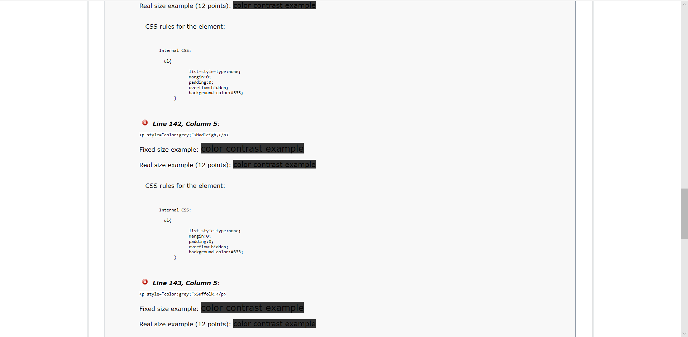

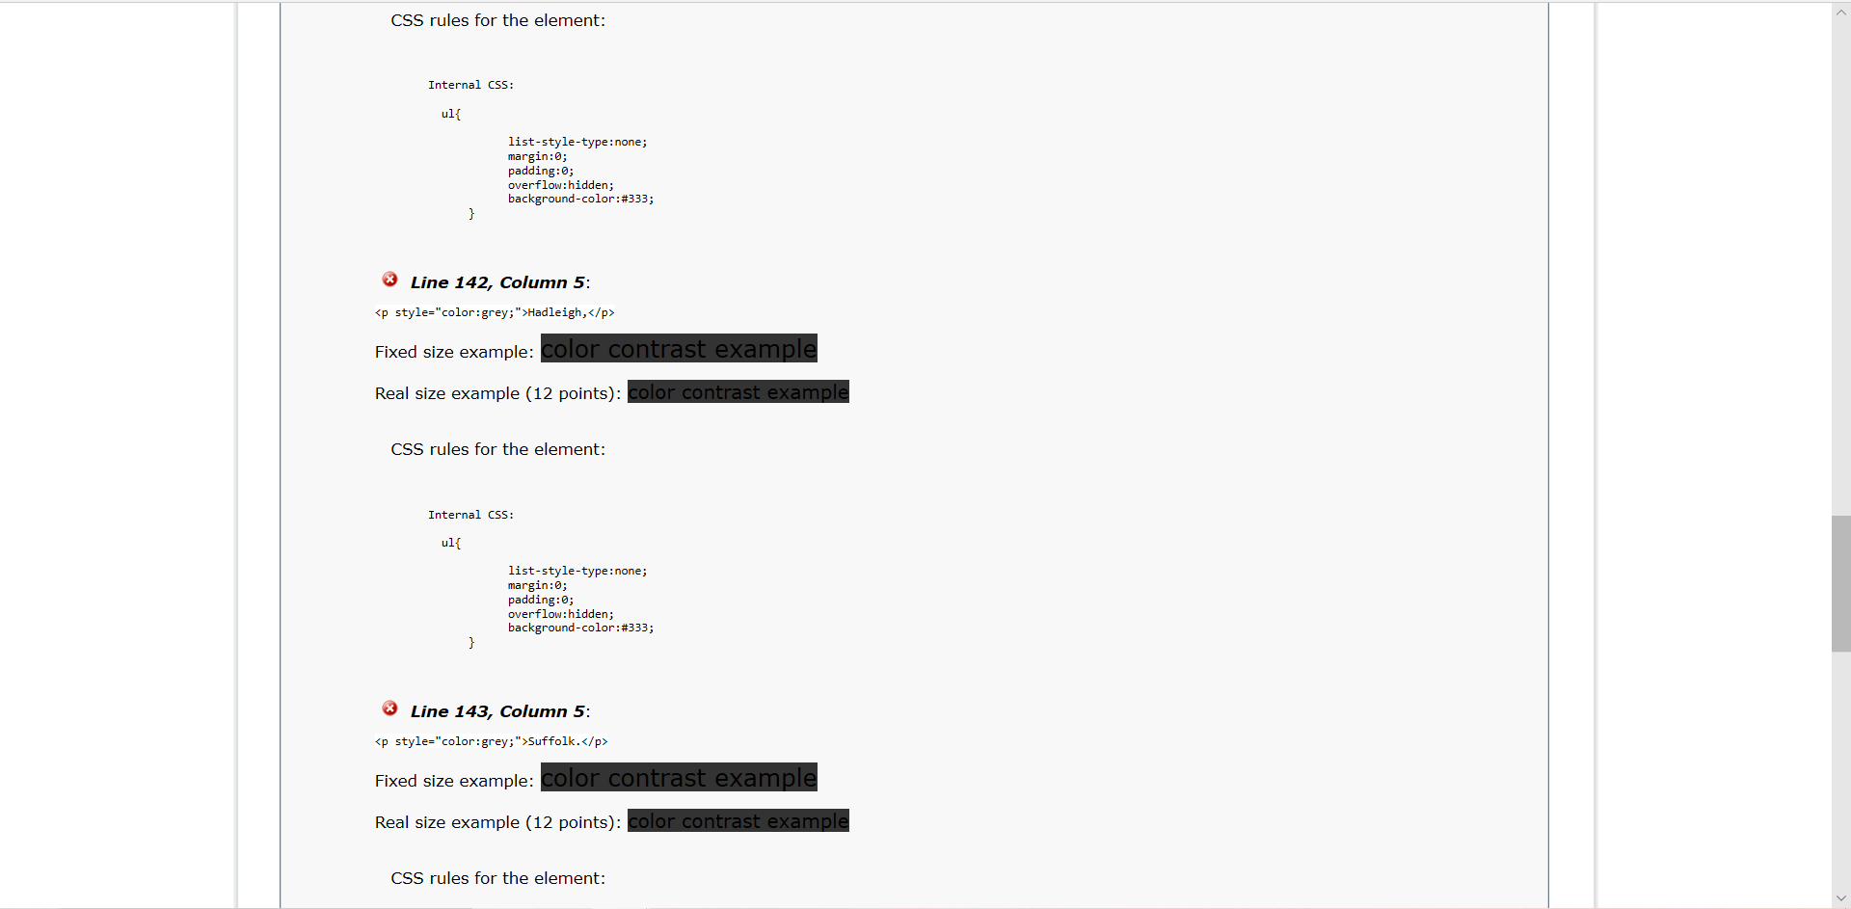

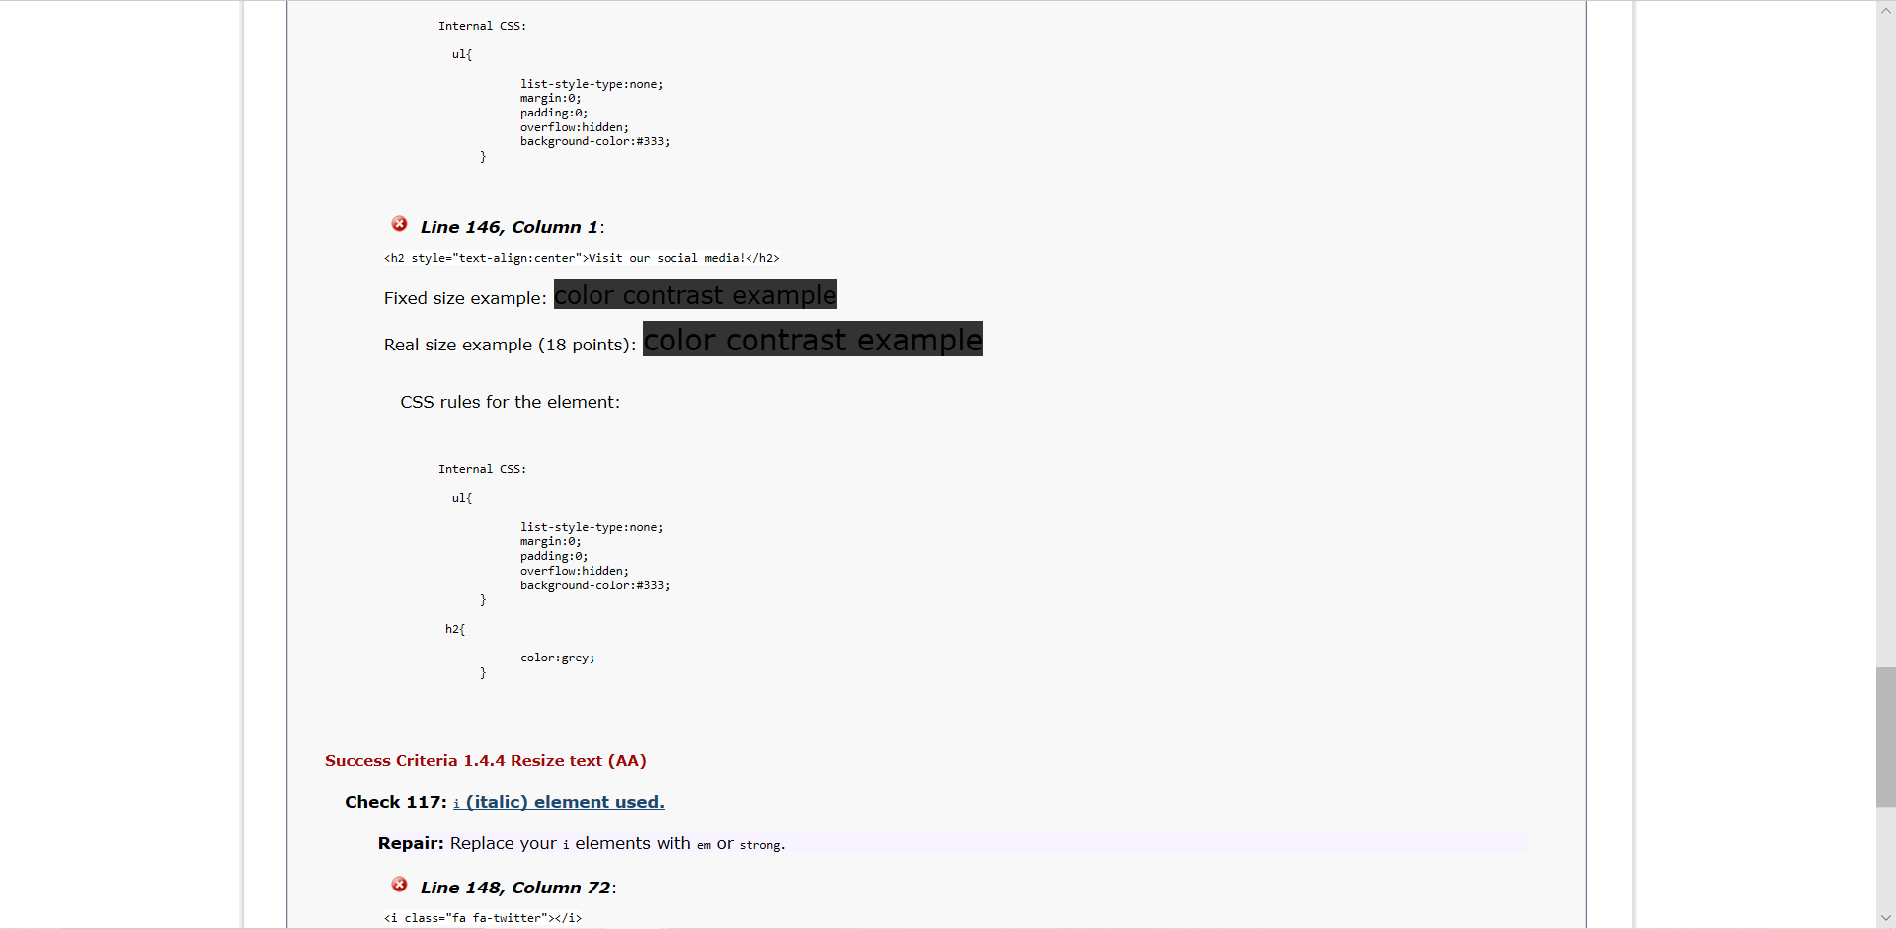

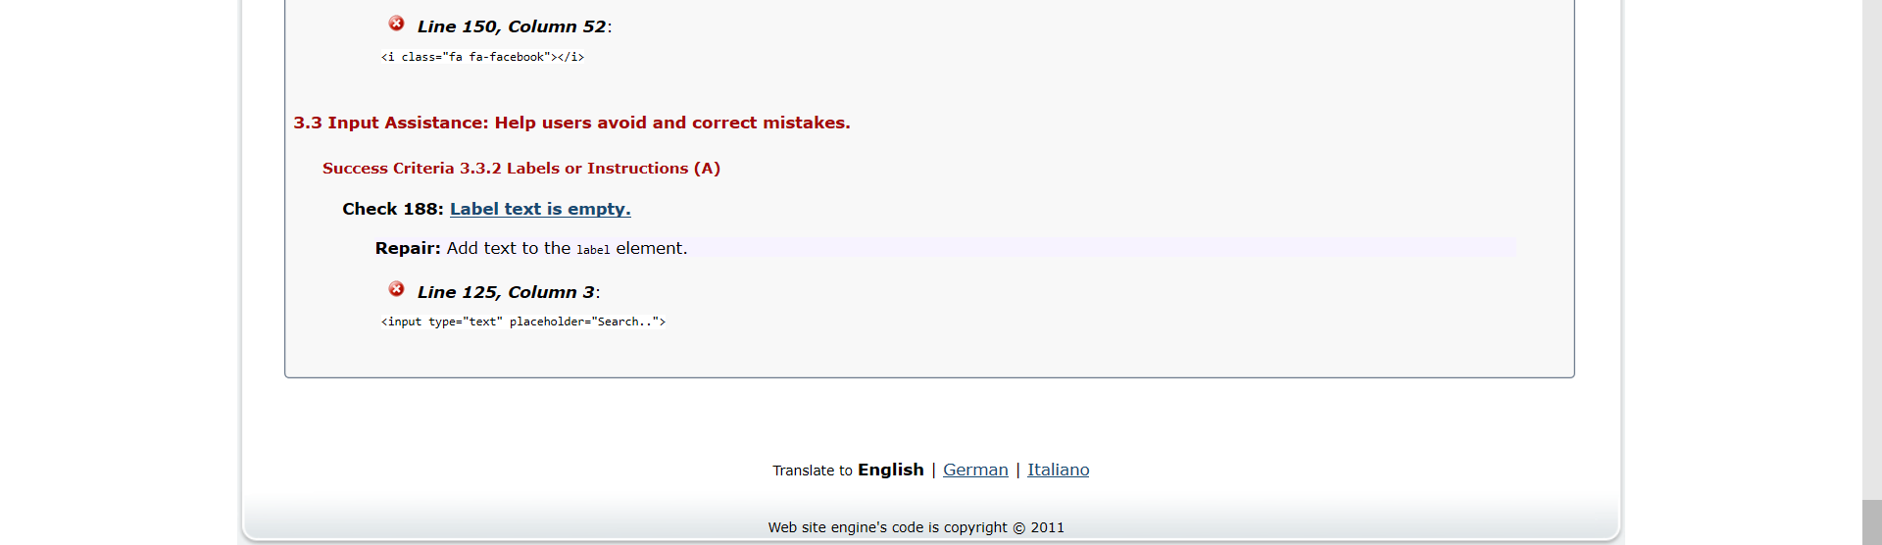

### Staff

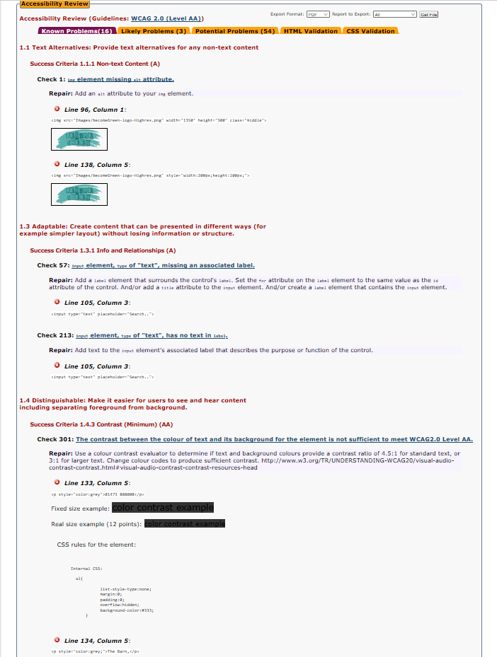

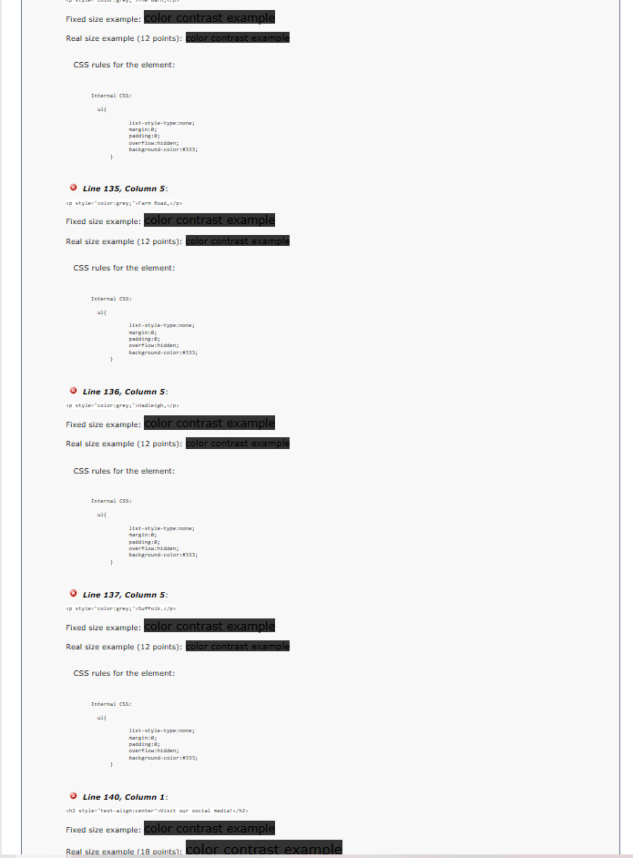

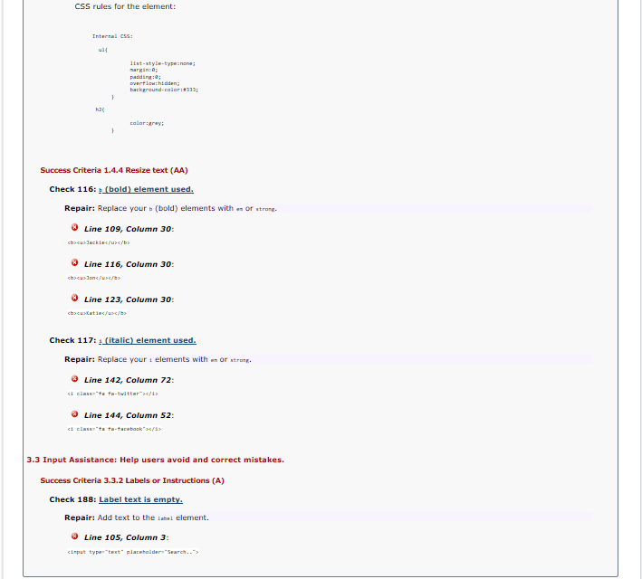

### Stock

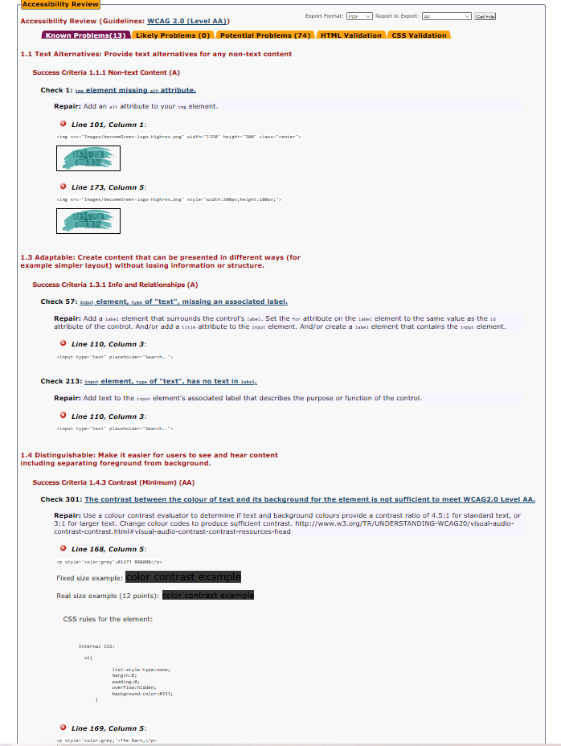

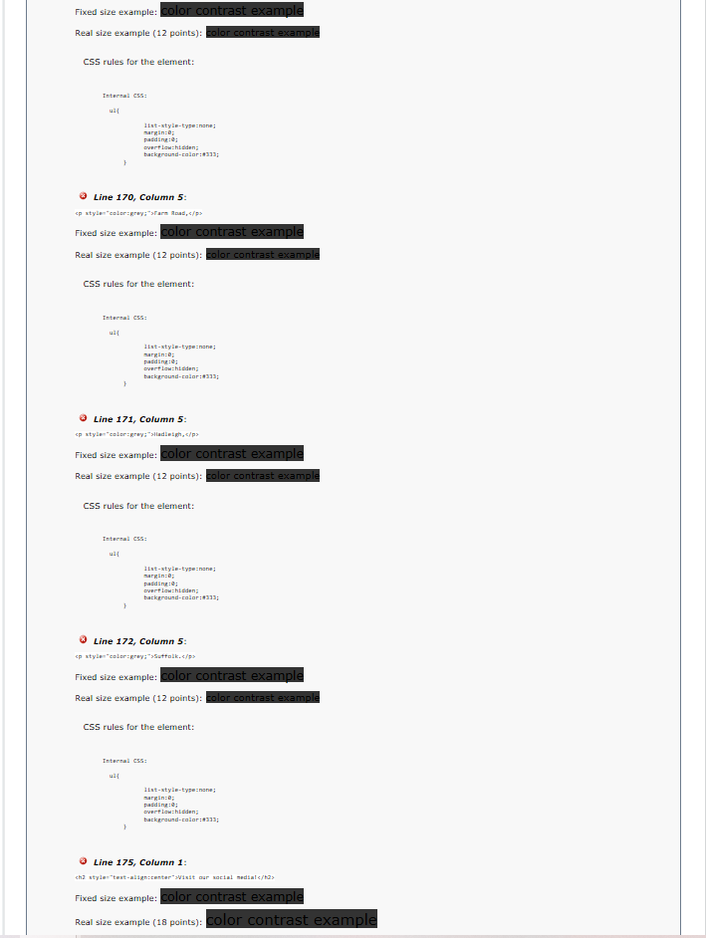

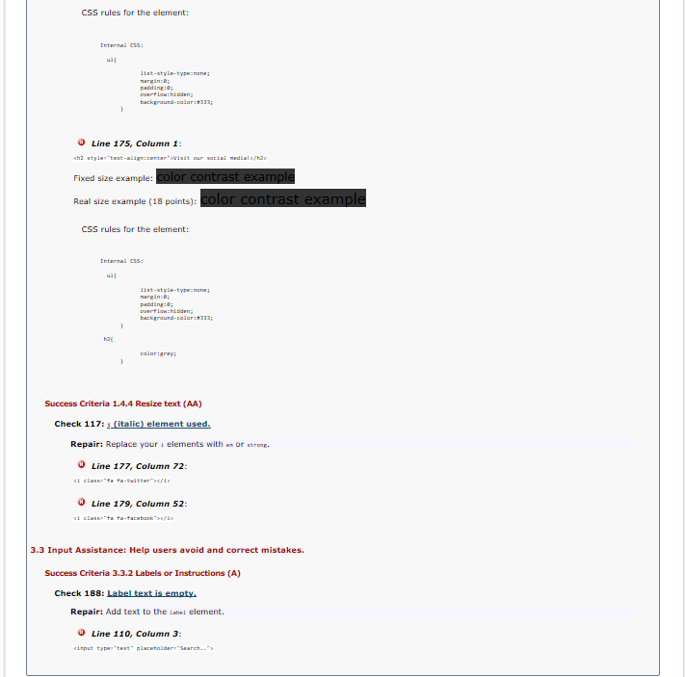

### Course

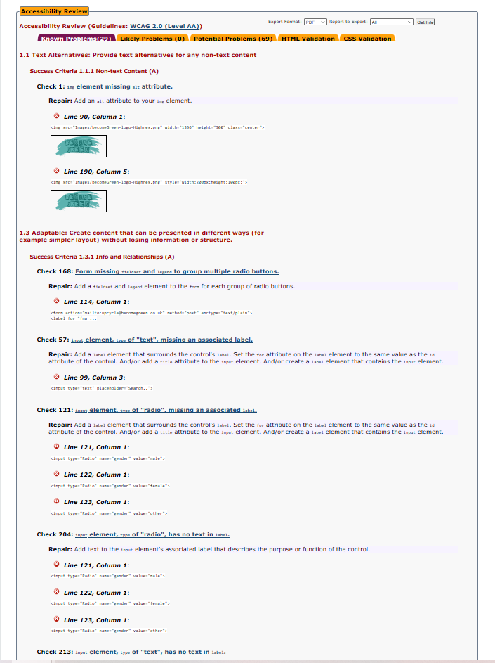

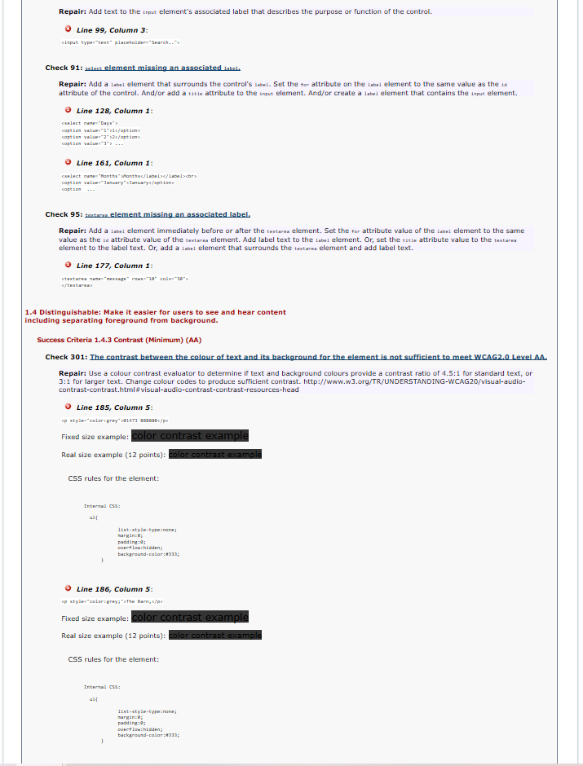

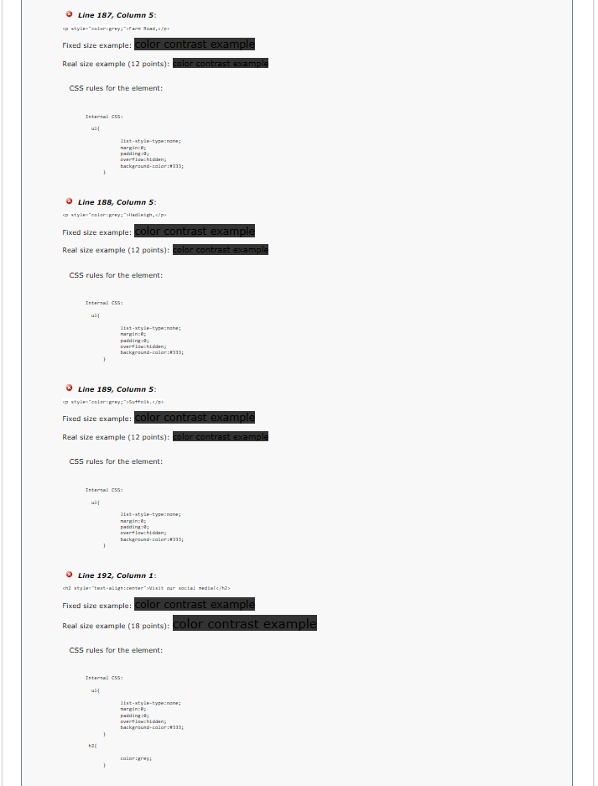

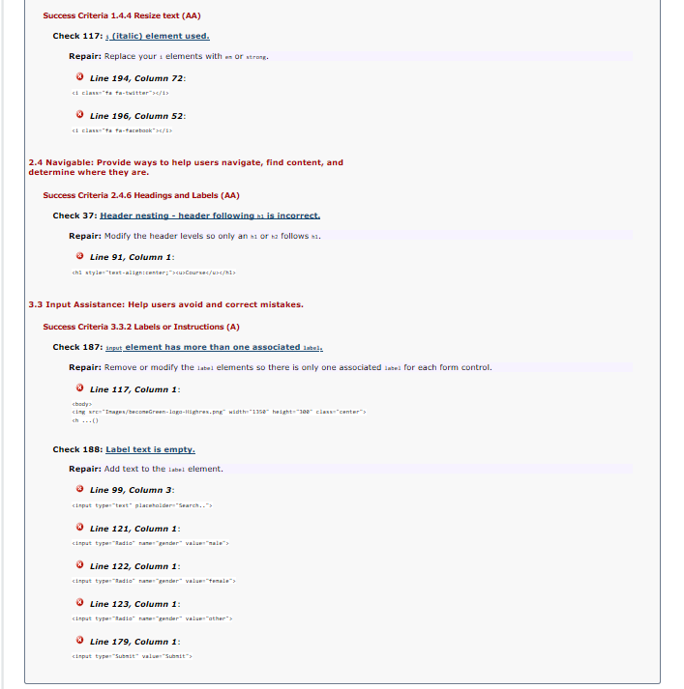

### Contact

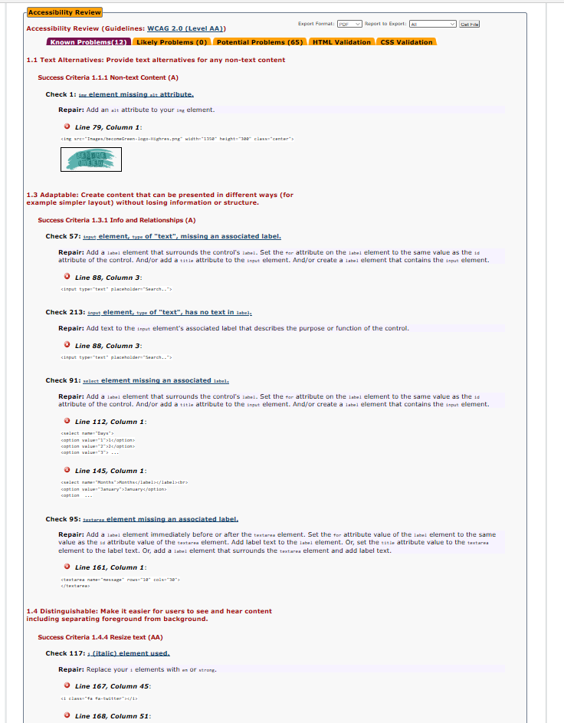

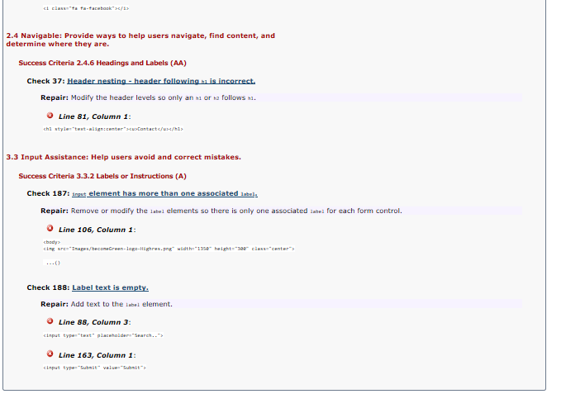

# Functionality Testing

## Form

### Course

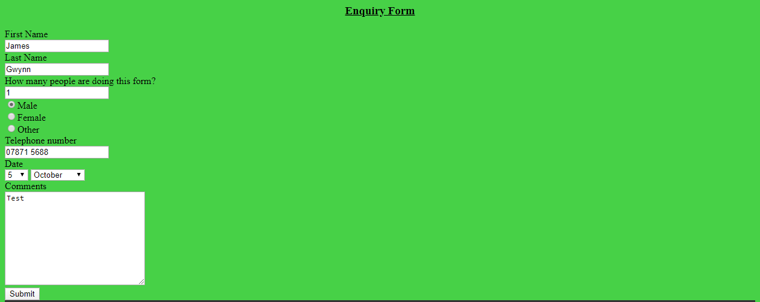

### Contact

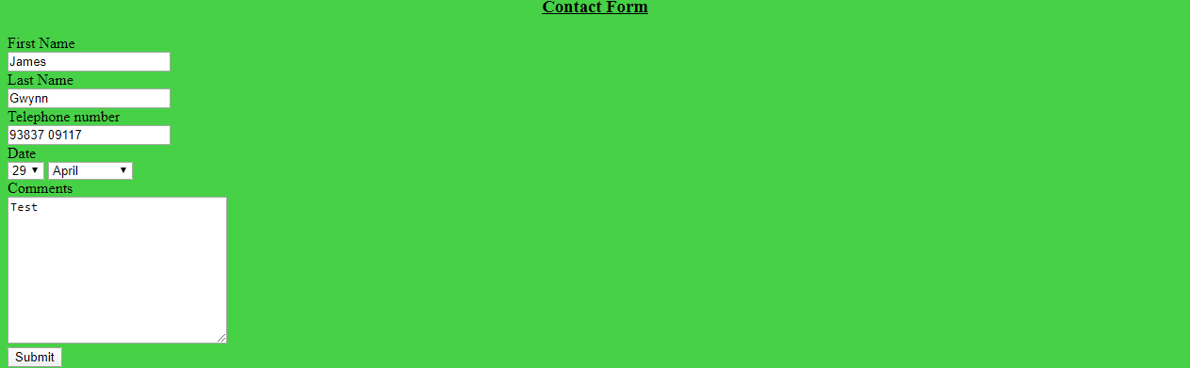

## Social Media

### Index, staff, stock and course

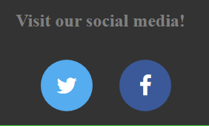

### Contact



### Twitter

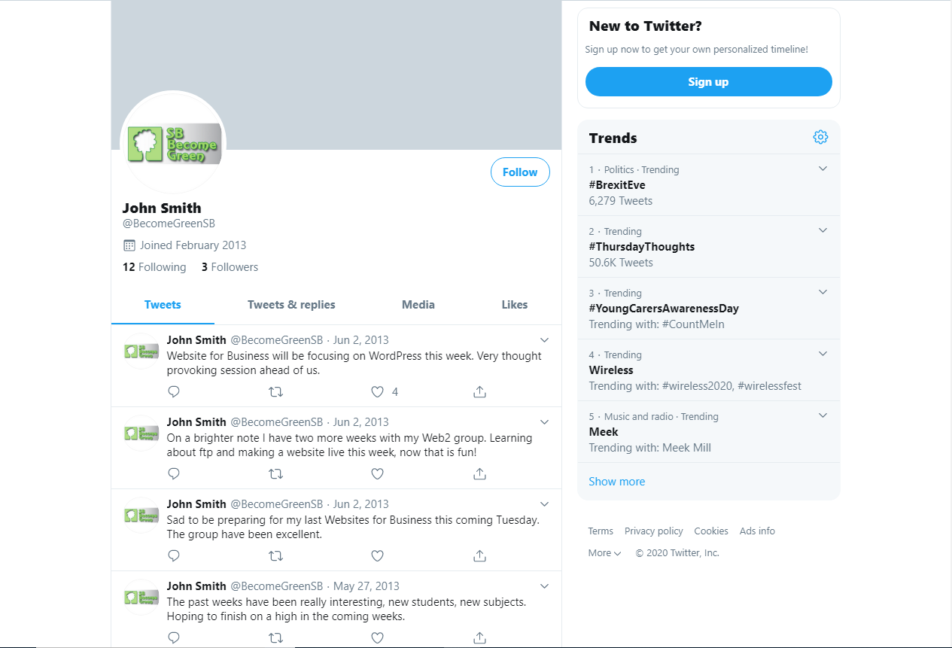

### Facebook

## YouTube

### index

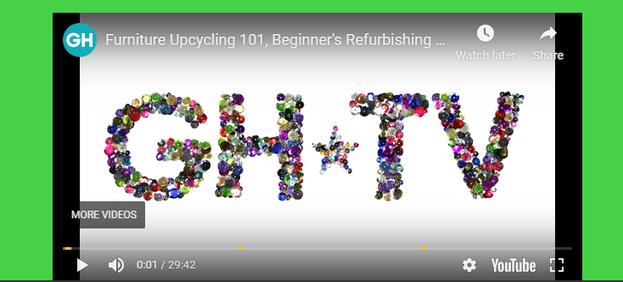

# Reflection

Some problems were encountered during this project both in the CSS and HTML code of the project. One example of this was that in figure 9 it was at first difficult to move both the logo and staff pictures to the centre of the page whilst also adjusting different heights and widths for the logo compared to the staff pictures. This was solved by creating a second function in CSS called “*middle”* which was used to move the logo to the centre whilst using the other function known as *“center”* to move the staff pictures to the middle of the page too. The sizes of the logo and staff pictures were adjusted using HTML. Another example is that there was some issue with getting social media buttons for Twitter and Facebook. However, the website Cloudflare was used in my HTML with all my web pages as shown in figure 8 for example and was used to help add social media buttons in the website linking to the official BecomeGreen Twitter page and a fake Facebook page made by myself (Cloudflare, 2020). W3 schools was also a website used for assistance with coding my website (w3schools.com, 2020). Some corrections on the HTML and CSS have also been made from the validation.

If this project was attempted again, links to more social media and a new logo would probably be created to make the website stand out more. Improving the logo could potentially showcase the website to be of higher quality and more social media links would increase accessibility as it shows more advertisement. As well as this one big aim for next time is to make the website accessible for mobile as this would also make it much more accessible to the targeted audience as it is able to be accessed from more devices and easier to reach as a result. This website aims to people of all ages who care about the environment, this will be helpful for the target audience as according to the Independent, *“nearly half of children aged five to 10 own mobile phones”* in the UK (Petter, 2020). More detail would also be added here and there such as a search button next to the search bar.

The website for the most part has remained true to the original plan as shown with the planned web page designs shown with figures 1-5. One slight difference that has been made is that the YouTube video is in the index in the final product while in the design it is in the course web page as shown with figure 4. The sitemap in figure 6 also remains mostly true to its planned design. As well as the planned file structure design in figure 7 as shown with figure 13.

Overall the project has mostly been a success, as a functioning and working website has been created. As well as all things that were planned to be included ended up being added in the end. Even if there are ambitions to add even more to it if there was more time.

# Conclusion

In conclusion a functioning and working website for a personal computer has successfully been made. Websites and tools have been used for assistance when creating the website, such as w3schools.com for HTML and CSS and Cloudflare as a tool to add functioning social media buttons for the Twitter and Facebook pages. As well as this codes such as the one used for the google map in figure 12 have been used to successfully post it on my website as shown in my Contact page. Another example is the YouTube video code shown in figure 8 and presented in my index page of the website.

Some suggested areas of improvement that was given is that a search bar button could be added next to the search bar so that it looks overall neater and have more detail shown in it. Some other suggested improvements that could be implemented if there was more time is that accessibility for mobile could be added. In fact, this is a big aim for further improve as better accessibility is extremely beneficial for a website. In fact a big factor in making a website high in a local websearch according to AMEinfo is to make it *“mobile friendly”* as *“nowadays more people are looking up websites on their mobile phones”* (AMEinfo, 2020).

The final product has stayed mostly the same as the originally planned designs of the web pages. There have however been slight changes between the planned designs and the final product. One example is that there is only the included the name and price of a specific product in the stock web page in the final product when in the planned design as shown in figure 3 there was originally planned to be a description as well. The reason why it is not like the planned design is because the table gets incredibly messy when the descriptions were put in, therefore it was decided that only the names and prices would be included in order for the table to look tidy. Another example is that as seen in the all the planned designs shown in figures 1-5 show that the social media buttons are square. The reason why they were changed to a circular shape is because it was decided that they personally look nicer and look better generally. As said before in the reflection another difference is also shown with the placement of the YouTube video. Overall the website has been created with most of the time referring back to the original design with slight differences.

# Bibliography

AMEinfo, 2020. *7 ways to rank high in a local website search.* [Online]   
Available at: https://www.ameinfo.com/industry/media/7-ways-to-rank-high-in-a-local-website-search  
[Accessed 30 January 2020].

Cloudflare, 2020. *Social Icons.* [Online]   
Available at: https://www.cloudflare.com/apps/social-icons  
[Accessed 30 January 2020].

Petter, O., 2020. *Nearly half of all five to 10-year-olds now have mobile phones report finds..* [Online]   
Available at: https://www.independent.co.uk/life-style/health-and-families/mobile-phones-children-kids-a9308266.html  
[Accessed 30 January 2020].

w3schools.com, 2020. *HTML. The language for building web pages.* [Online]   
Available at: https://www.w3schools.com/default.asp  
[Accessed 30 January 2020].

# Appendix A ­- Design Document

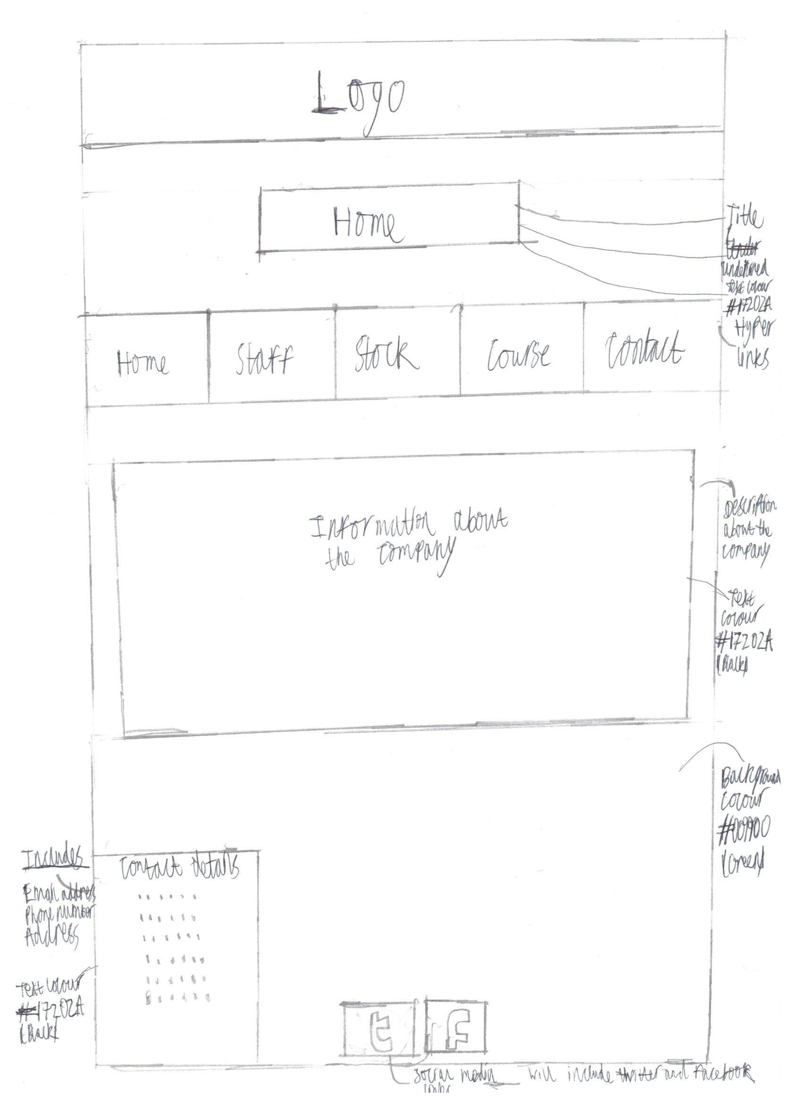

Figure : Index design

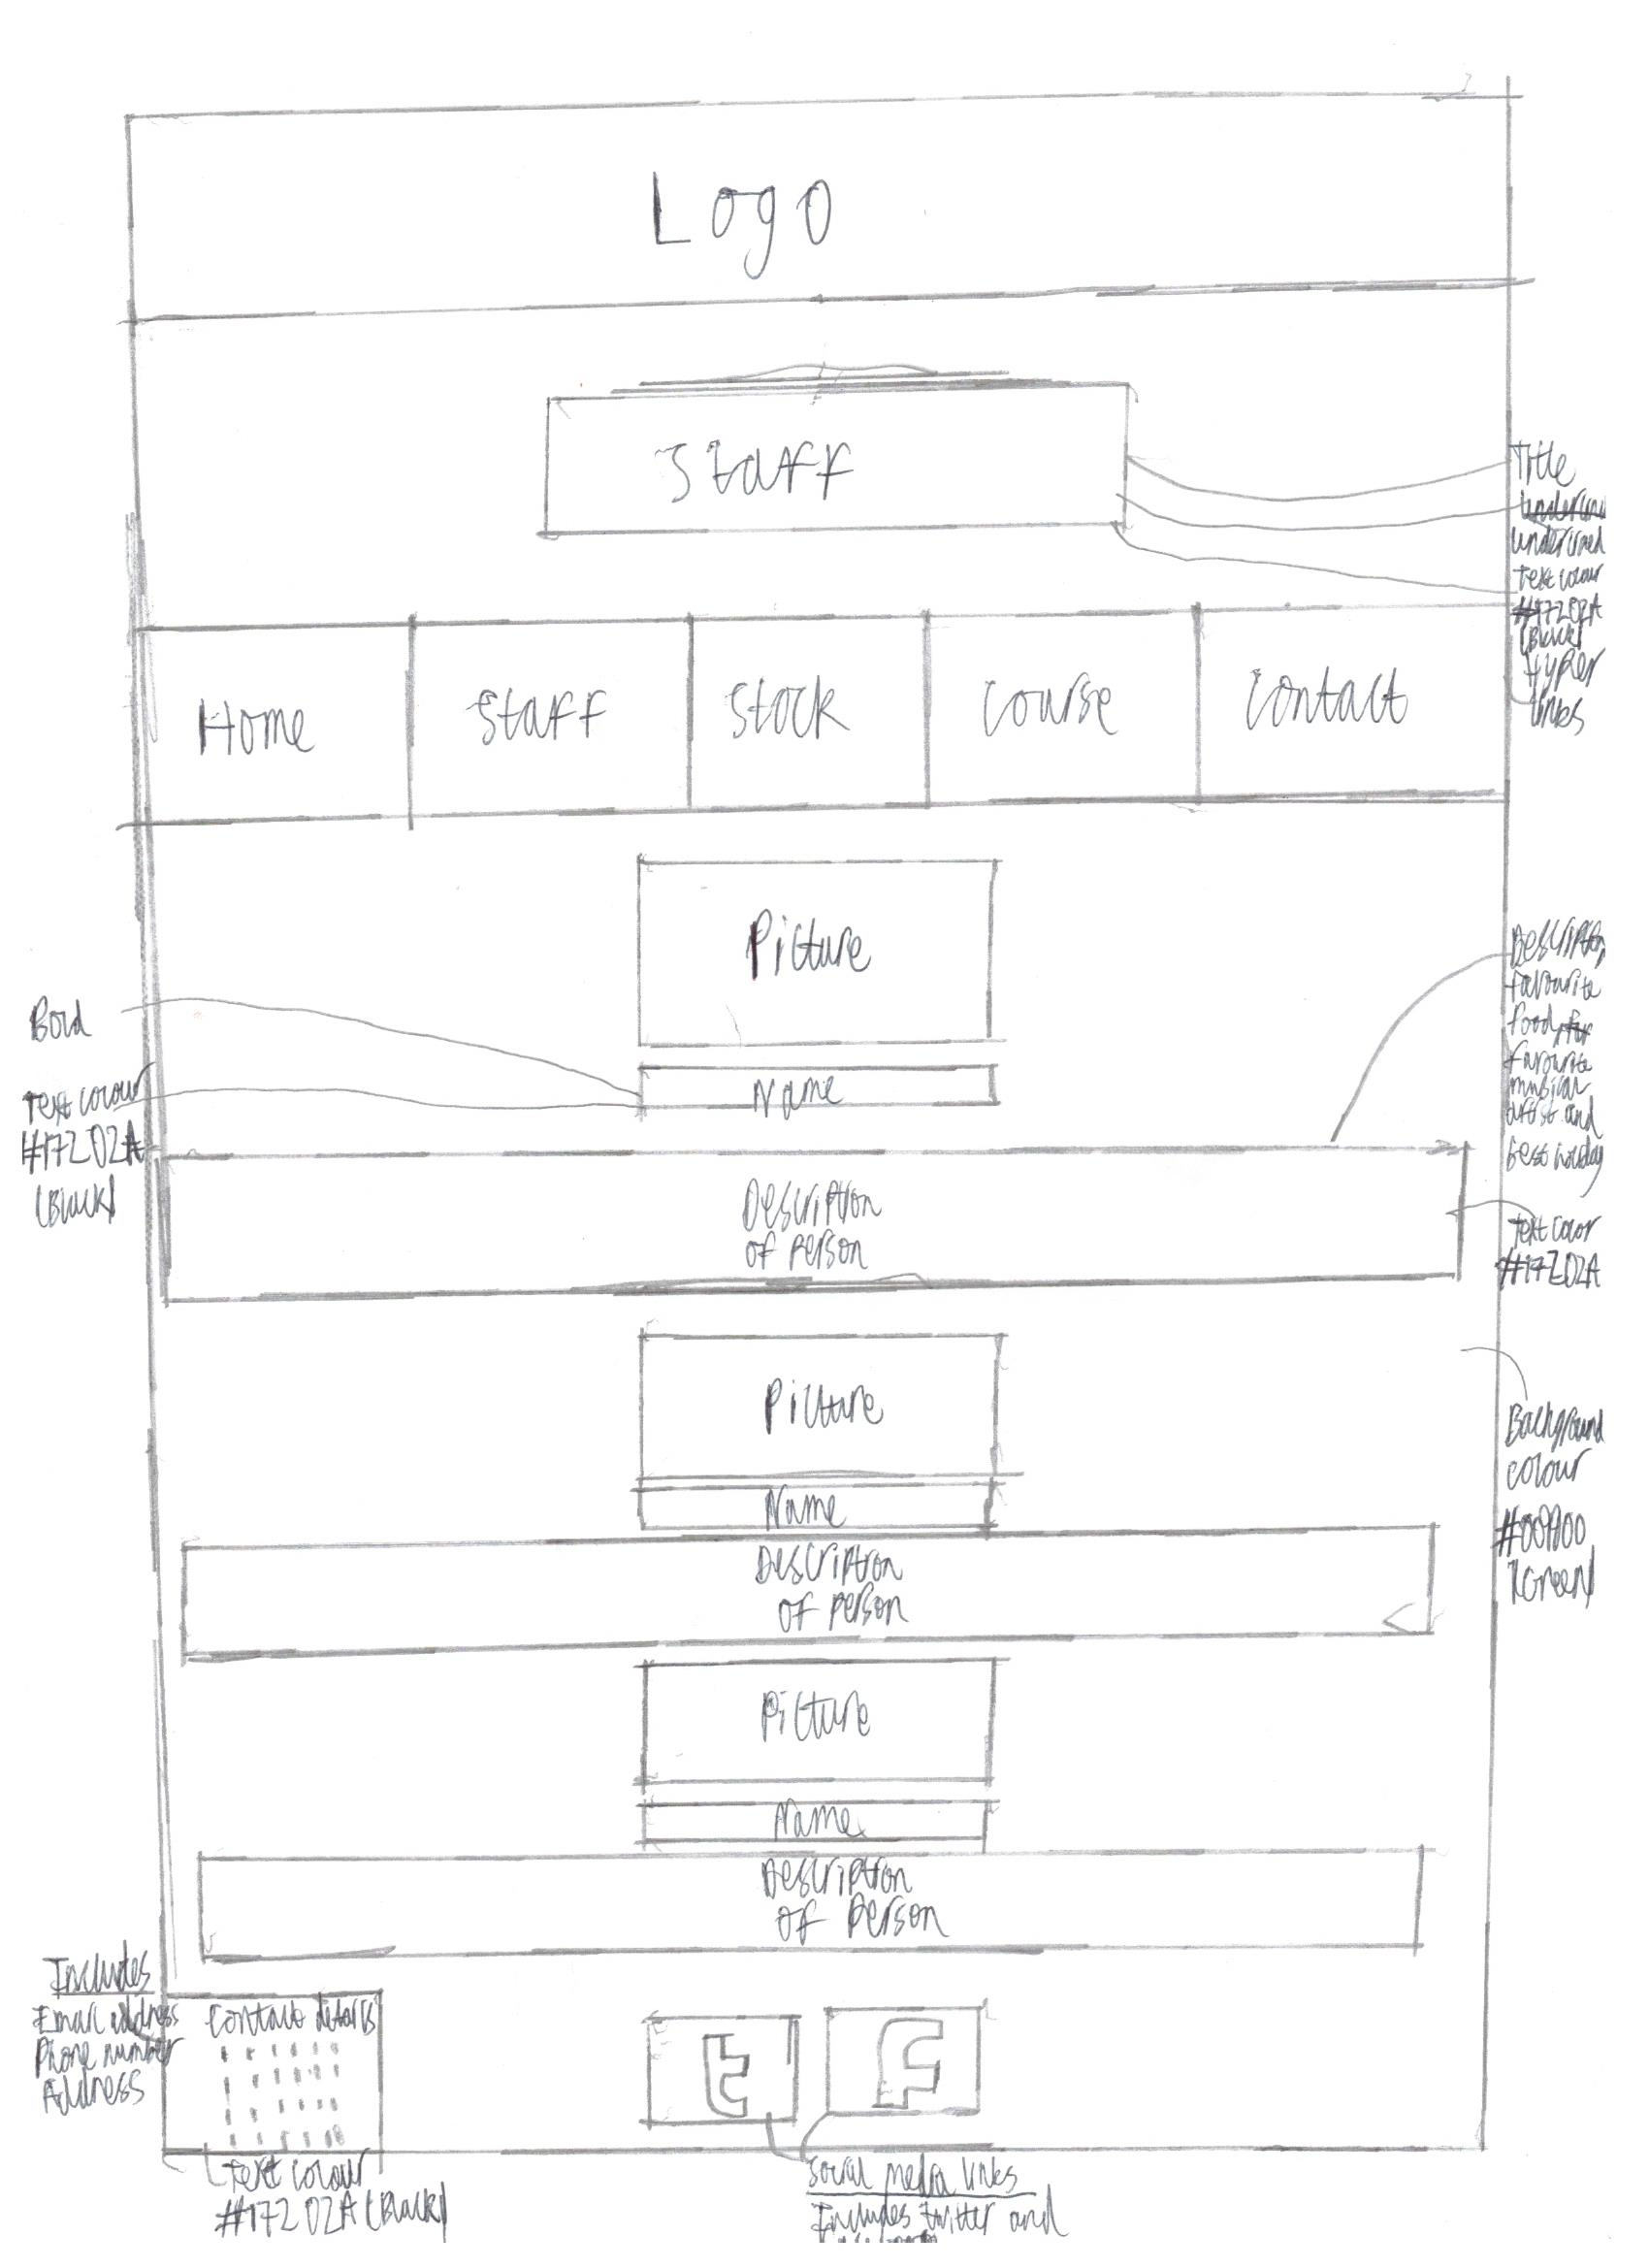

Figure : Staff design

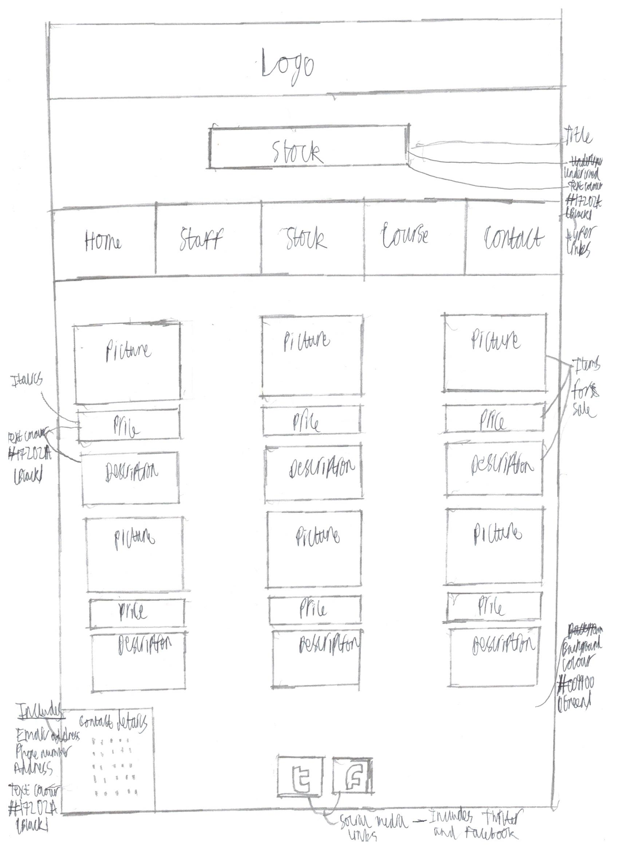

Figure : Stock design

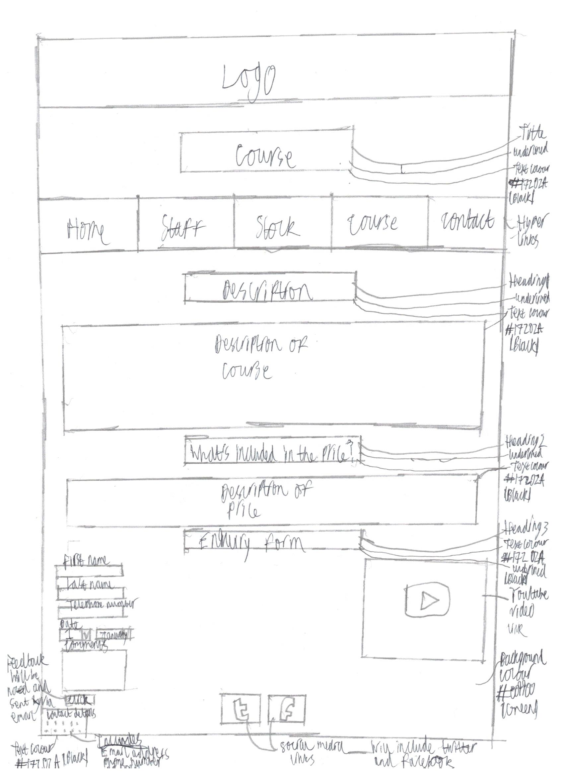

Figure : Course design

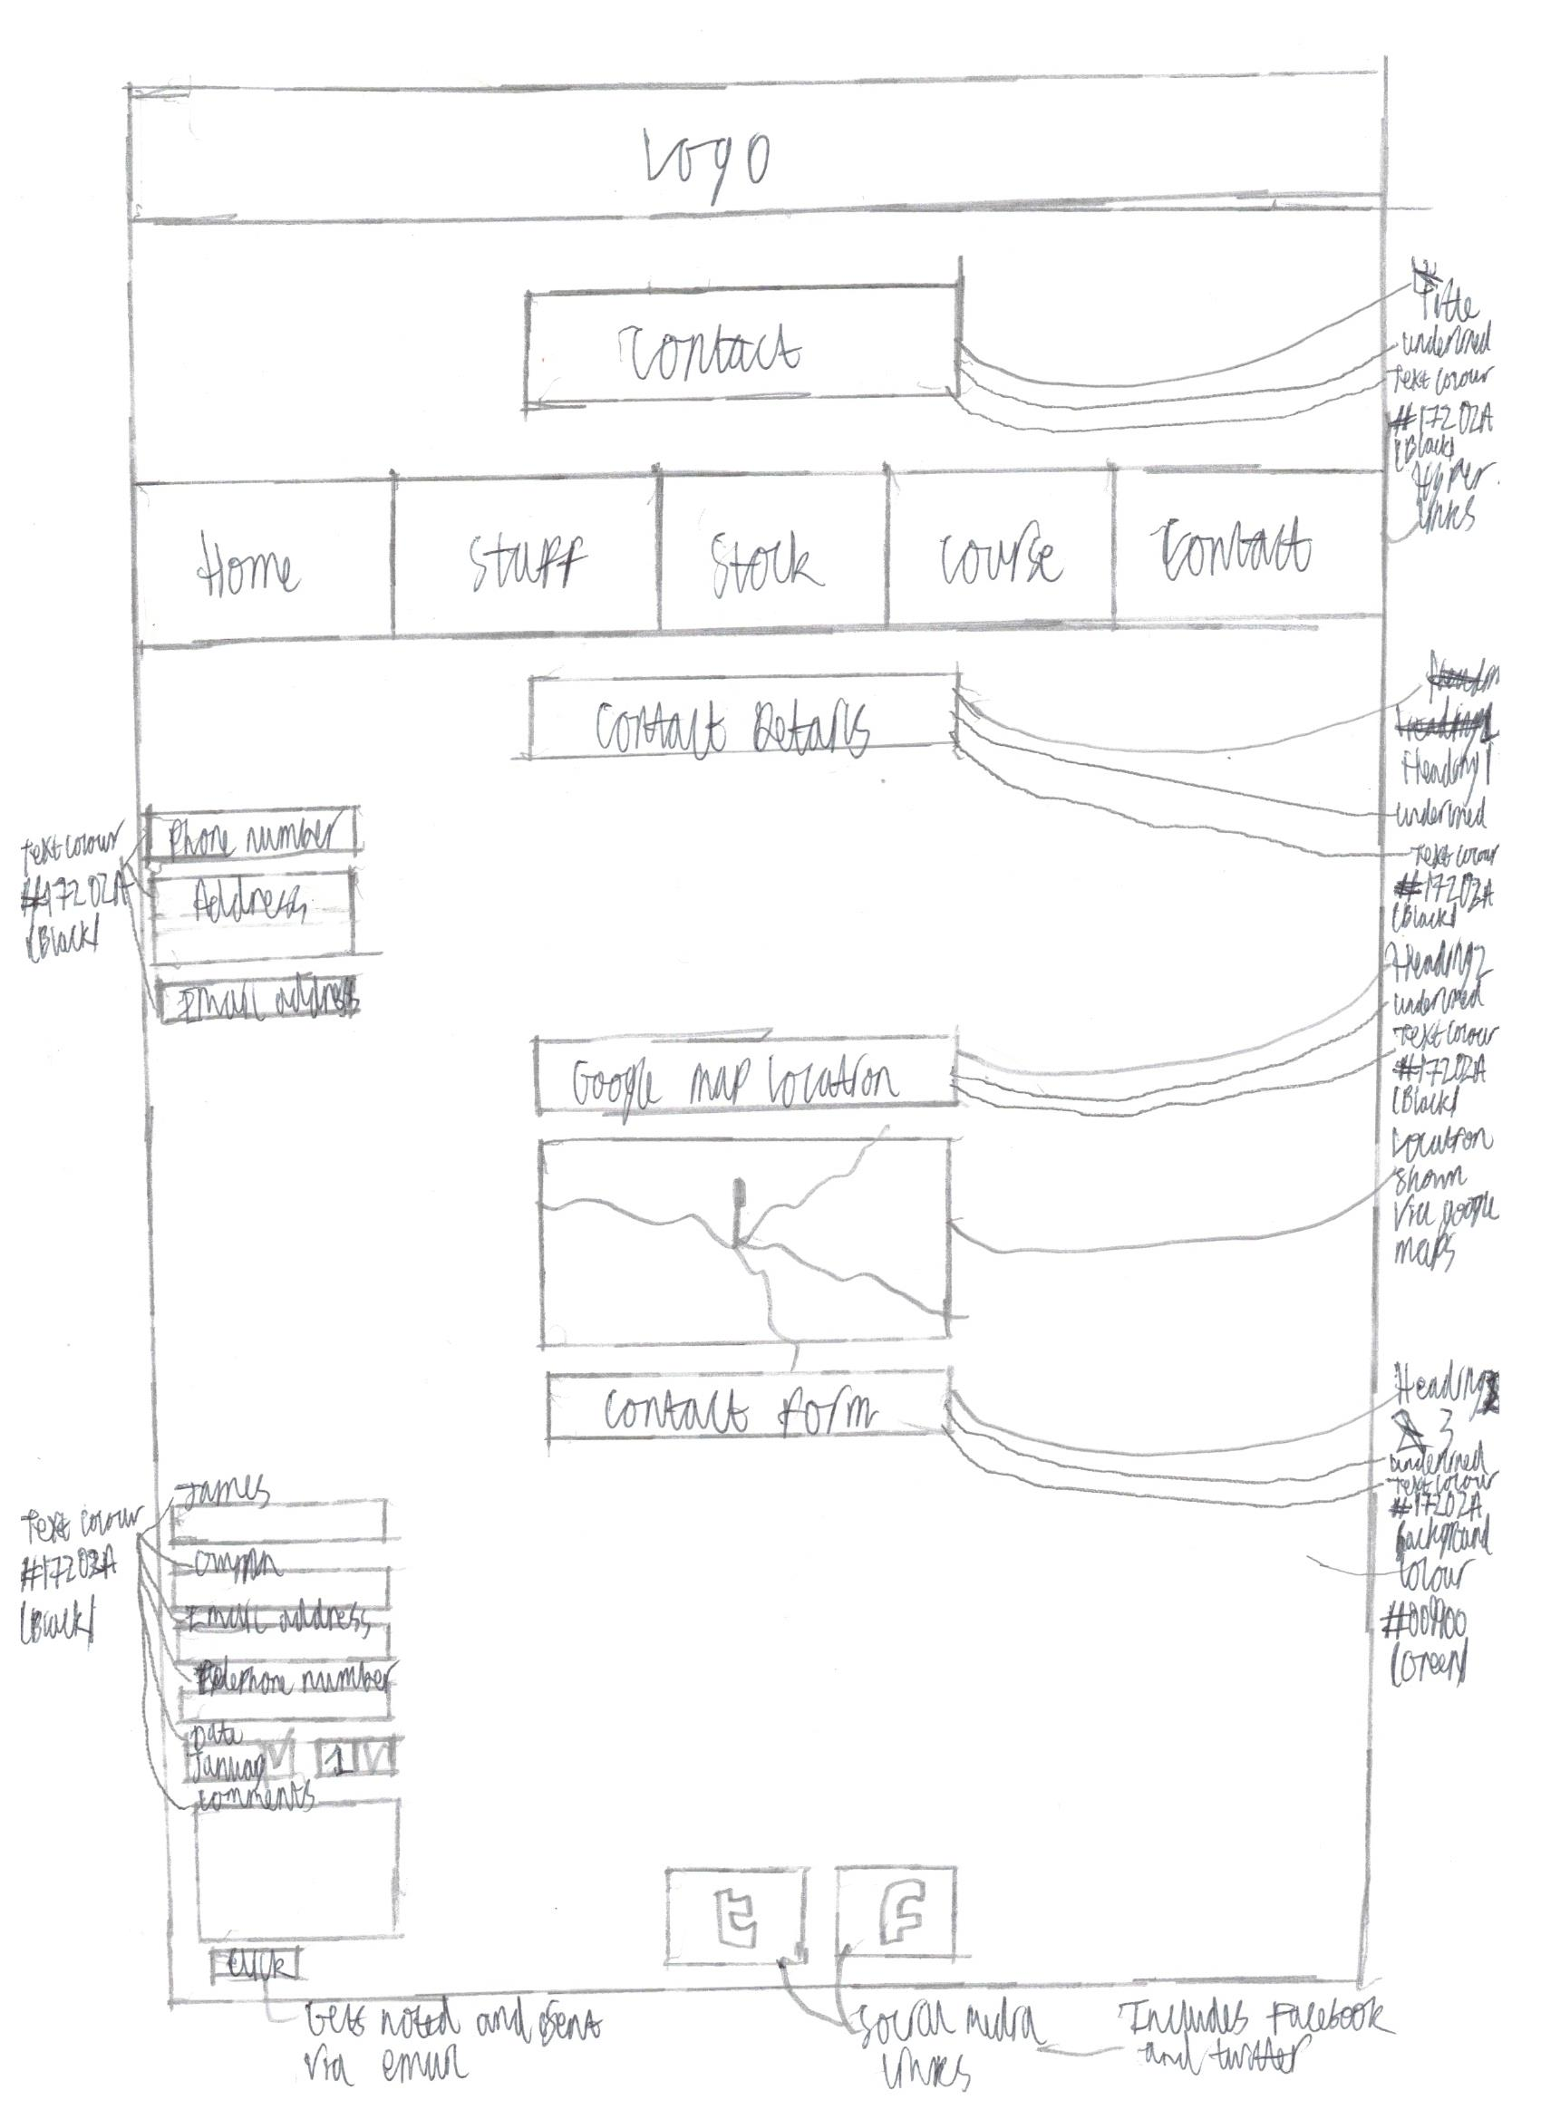

Figure : Contact design

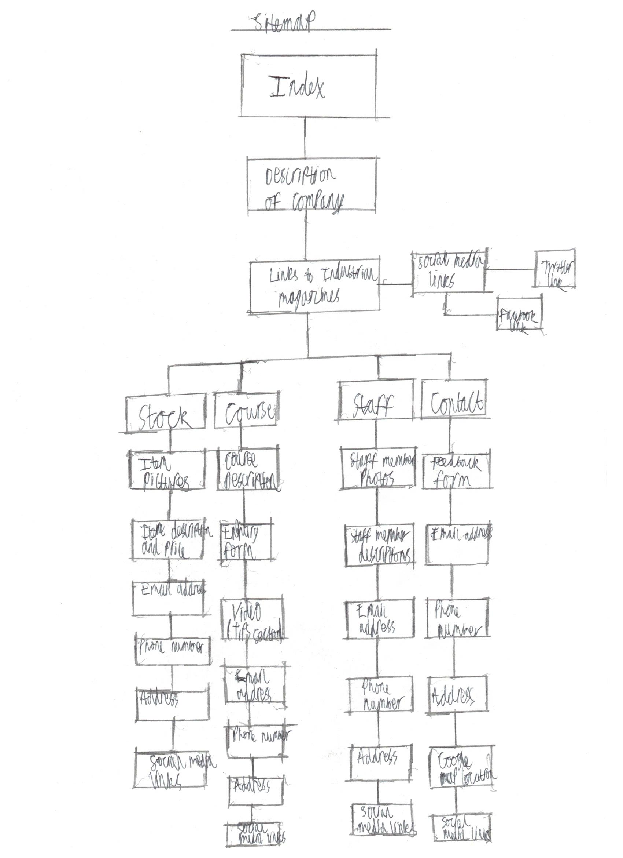

Figure : Sitemap design

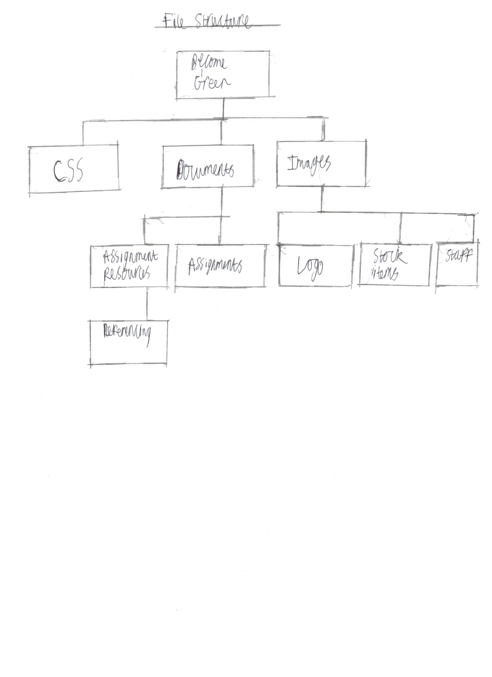

Figure : File structure design

# Appendix B – Codes

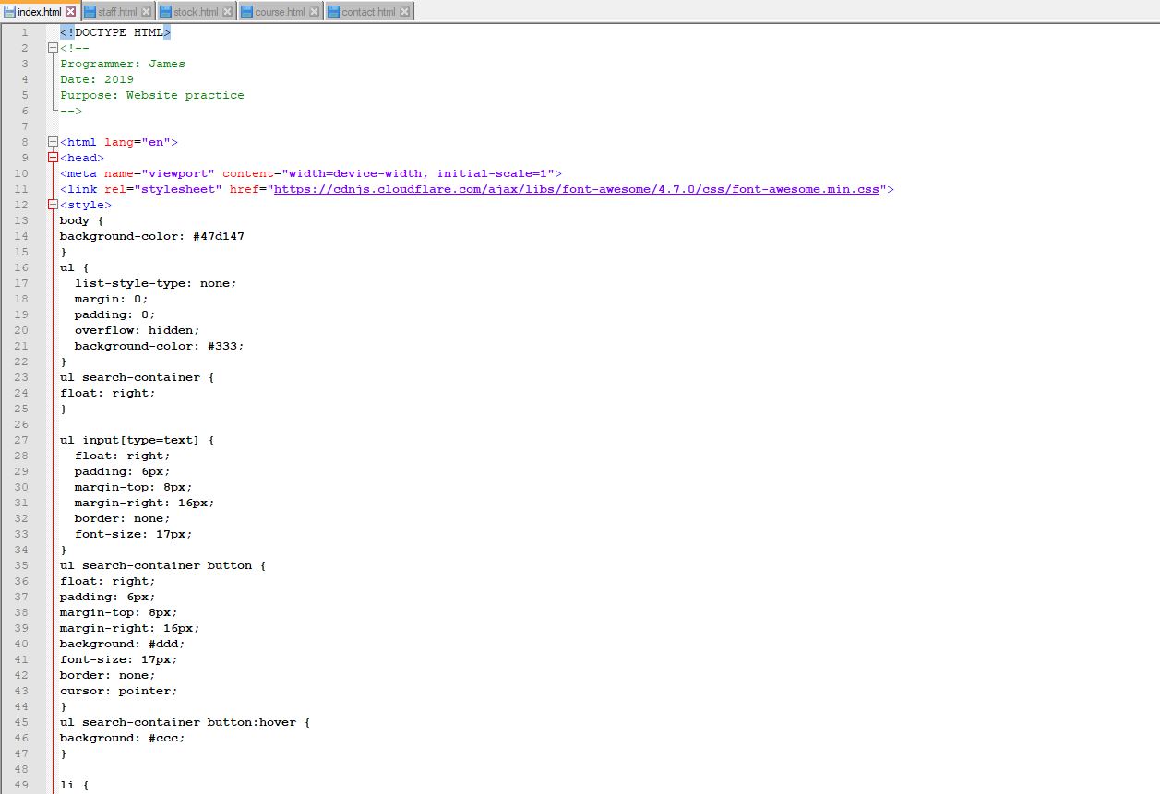

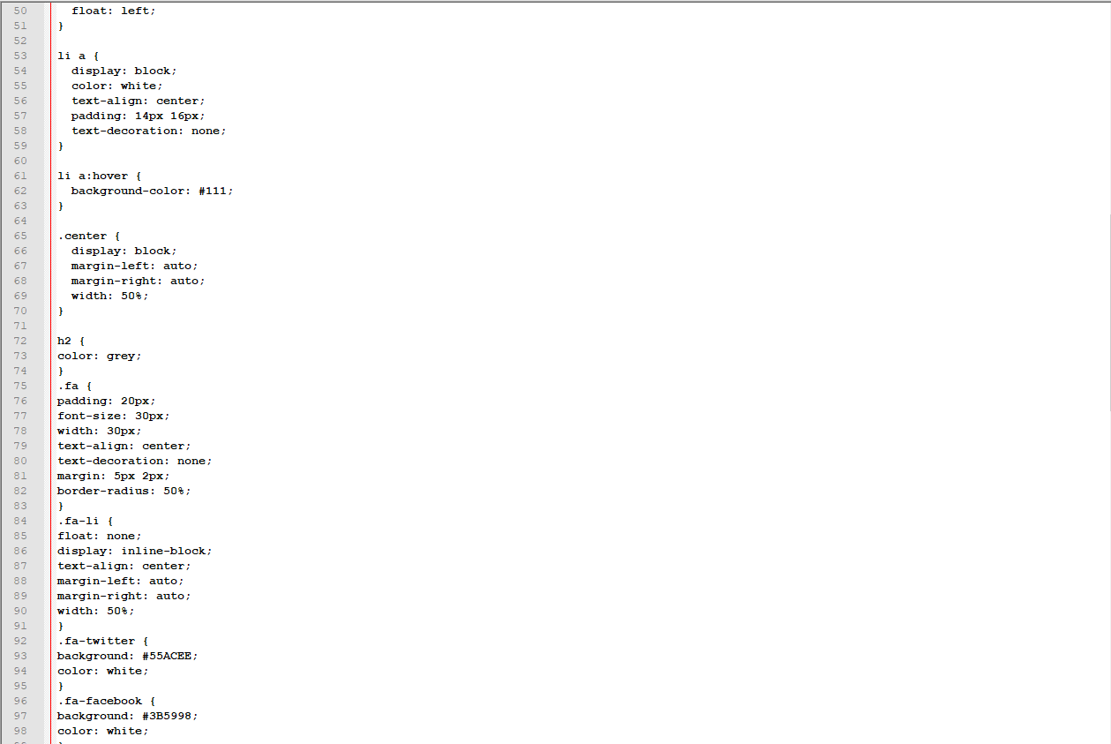

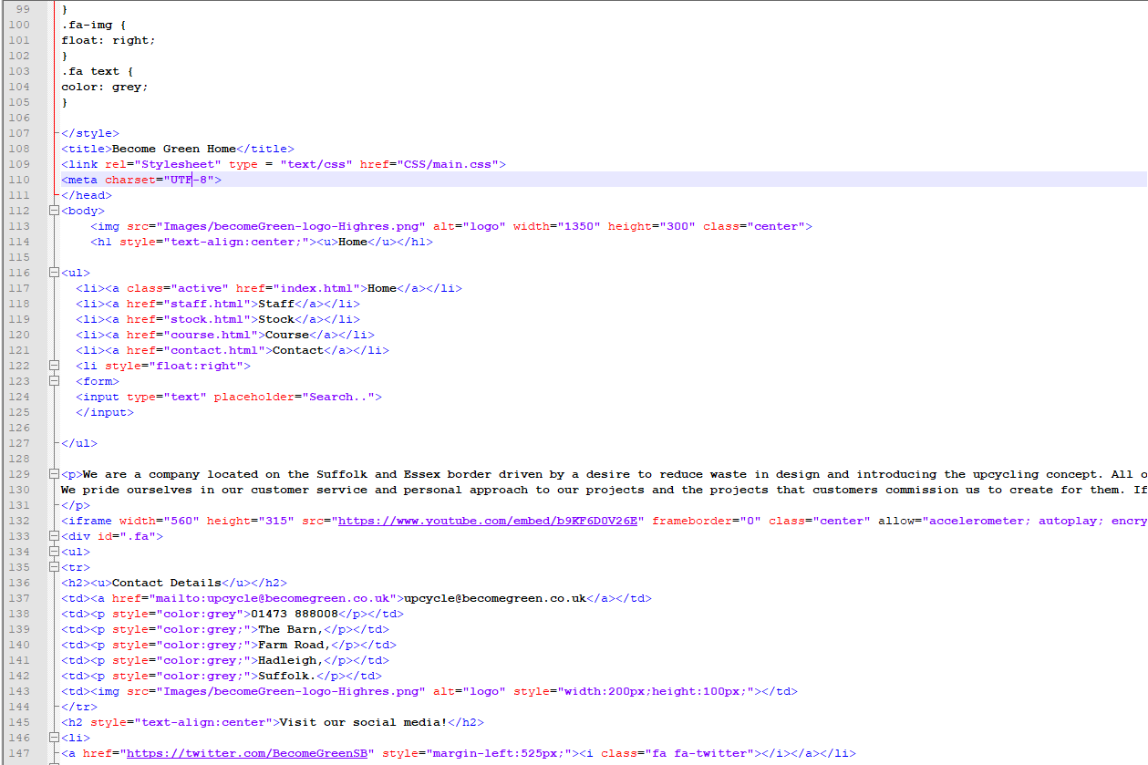

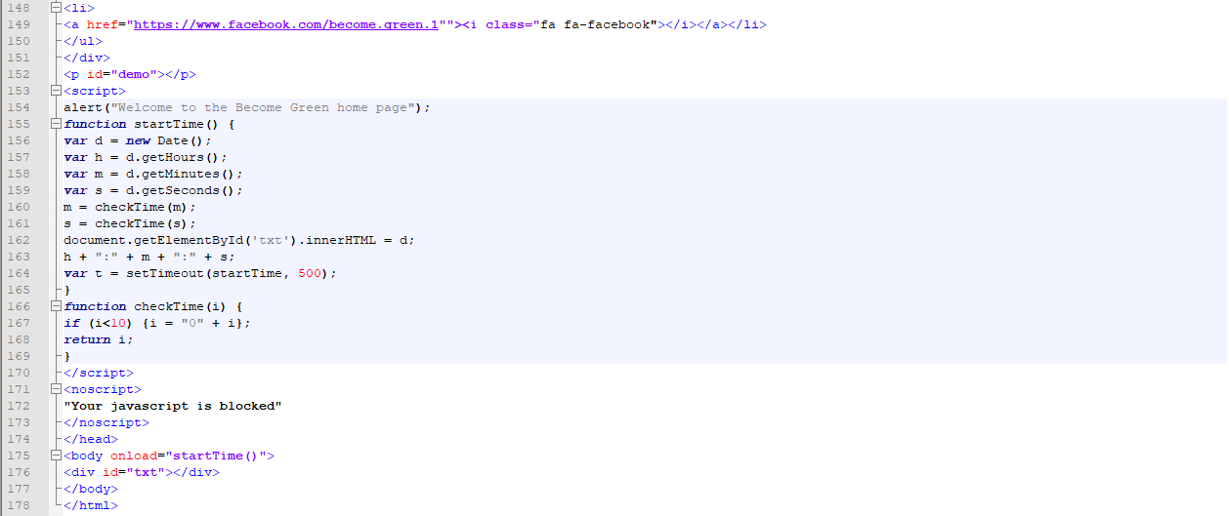

Figure : Index code

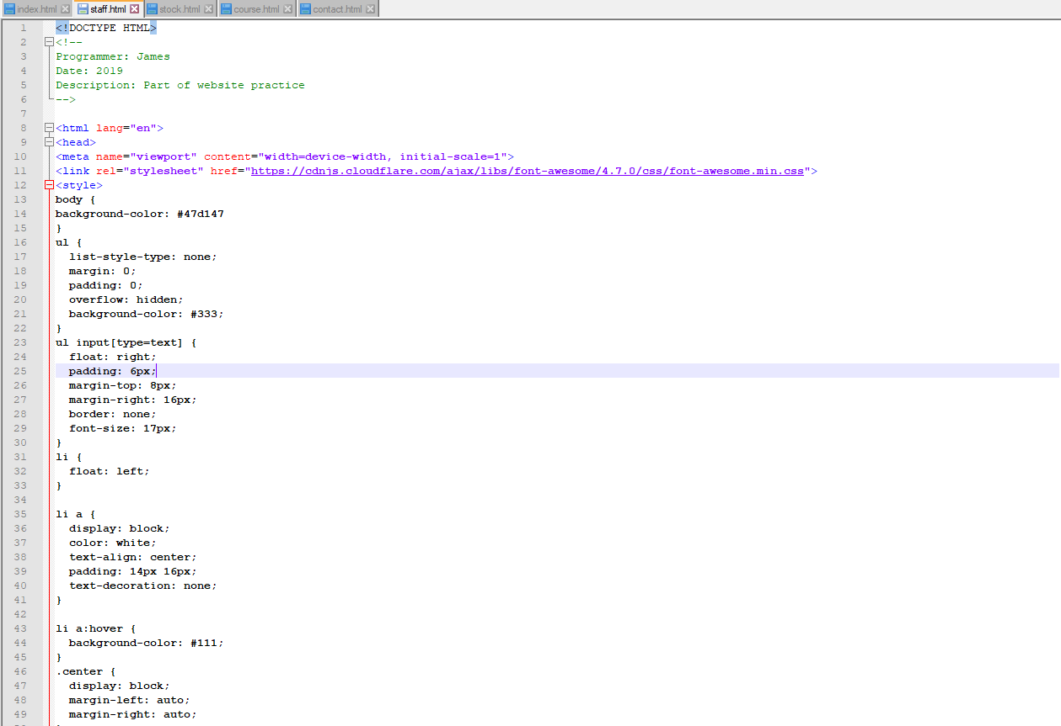

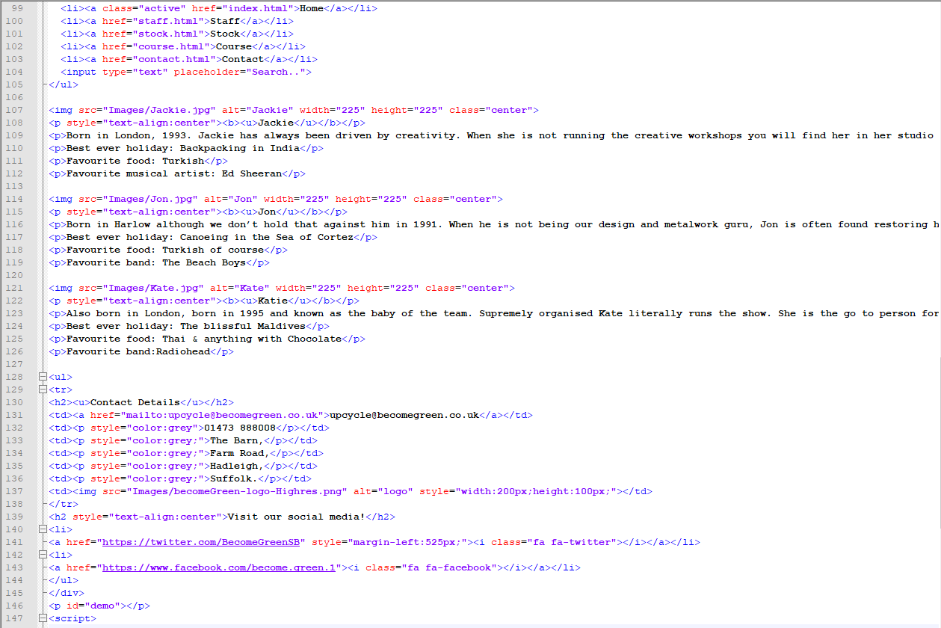

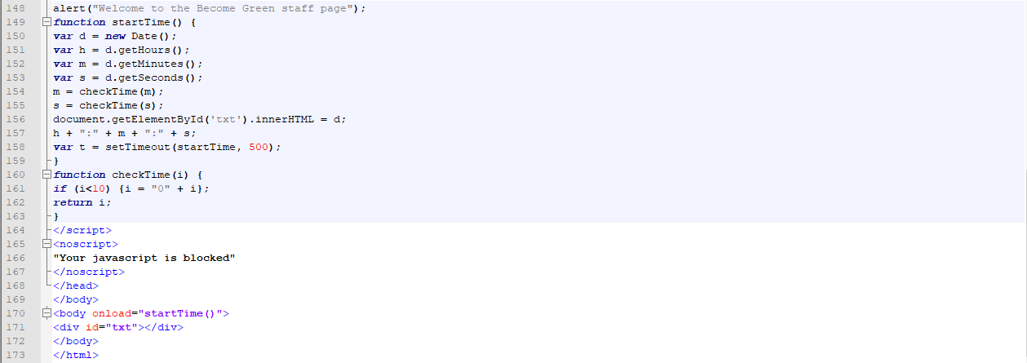

Figure : Staff code

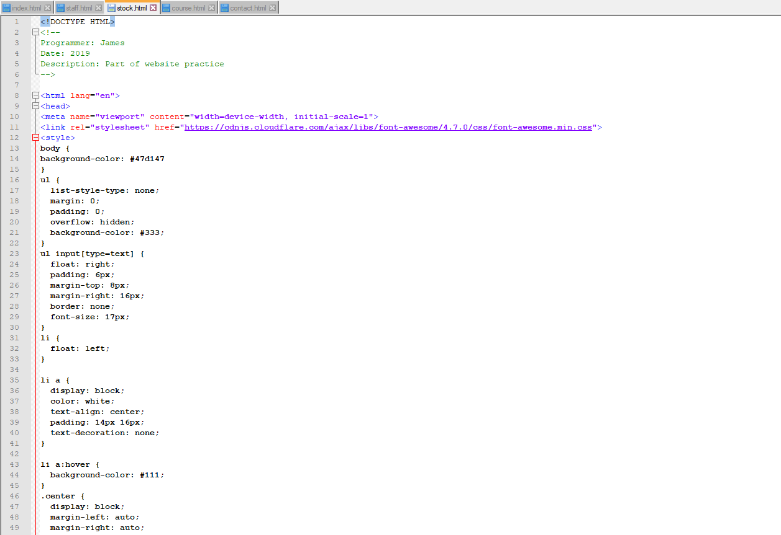

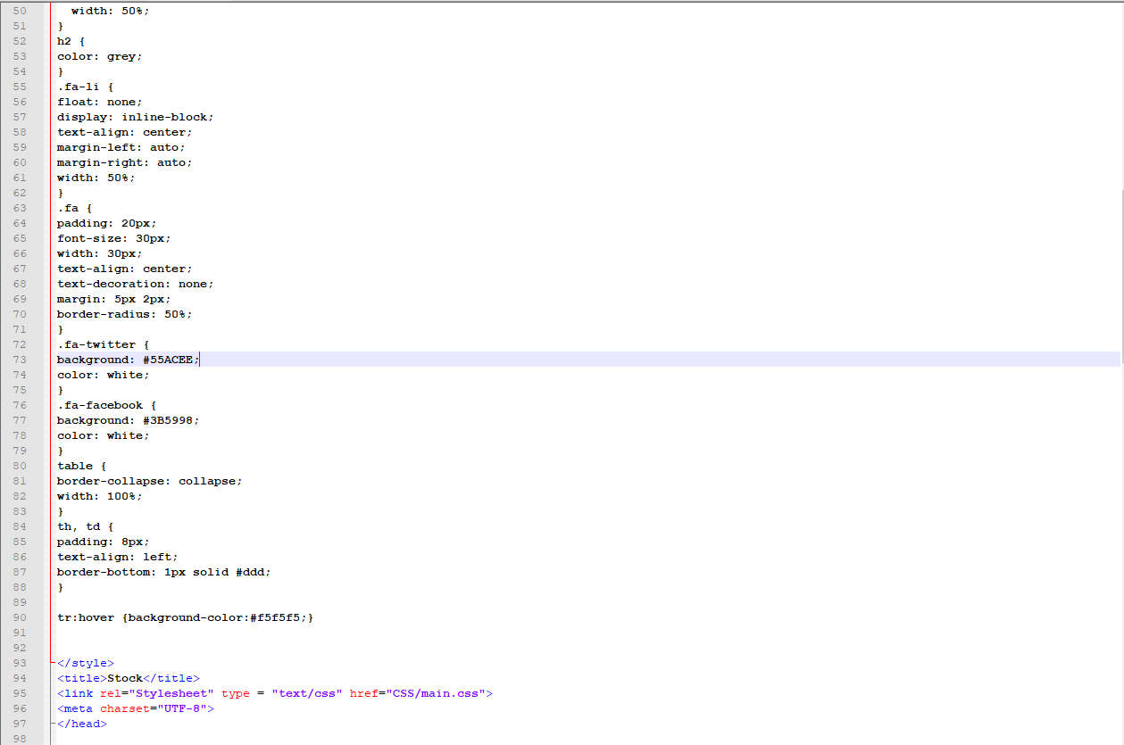

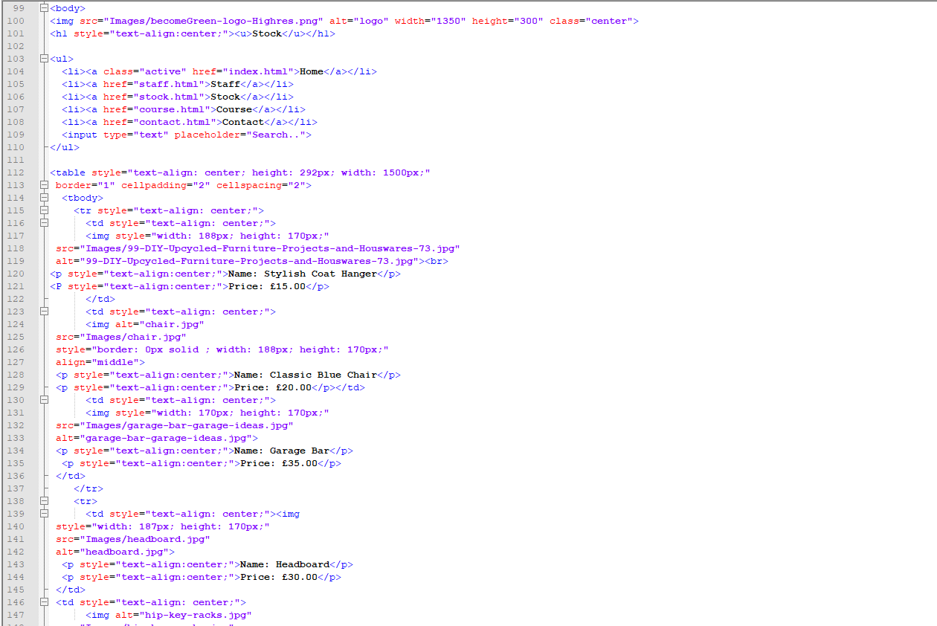

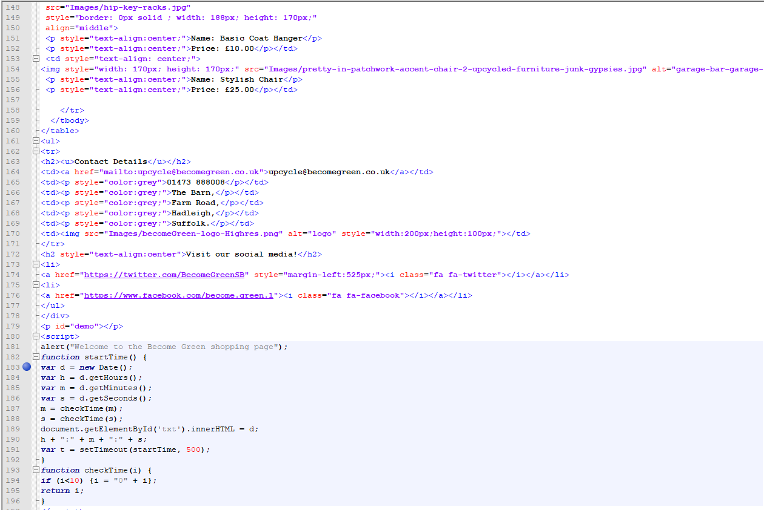

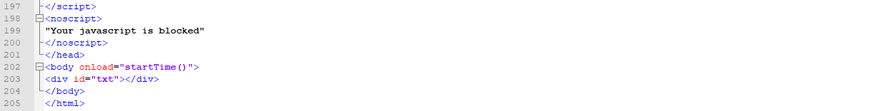

Figure : Stock code

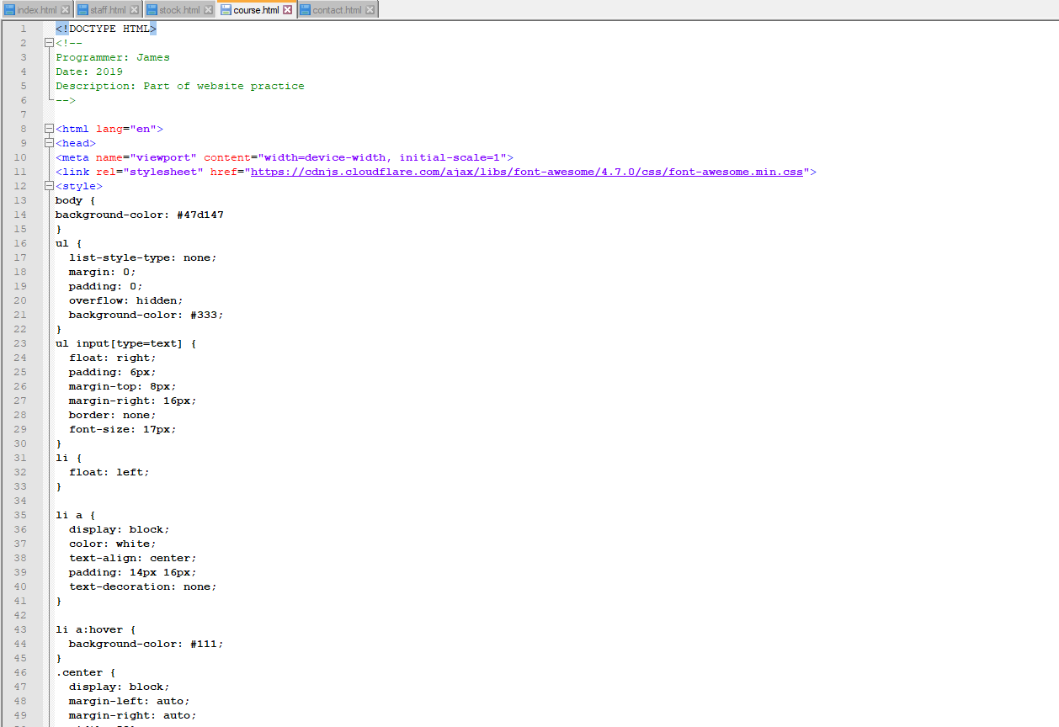

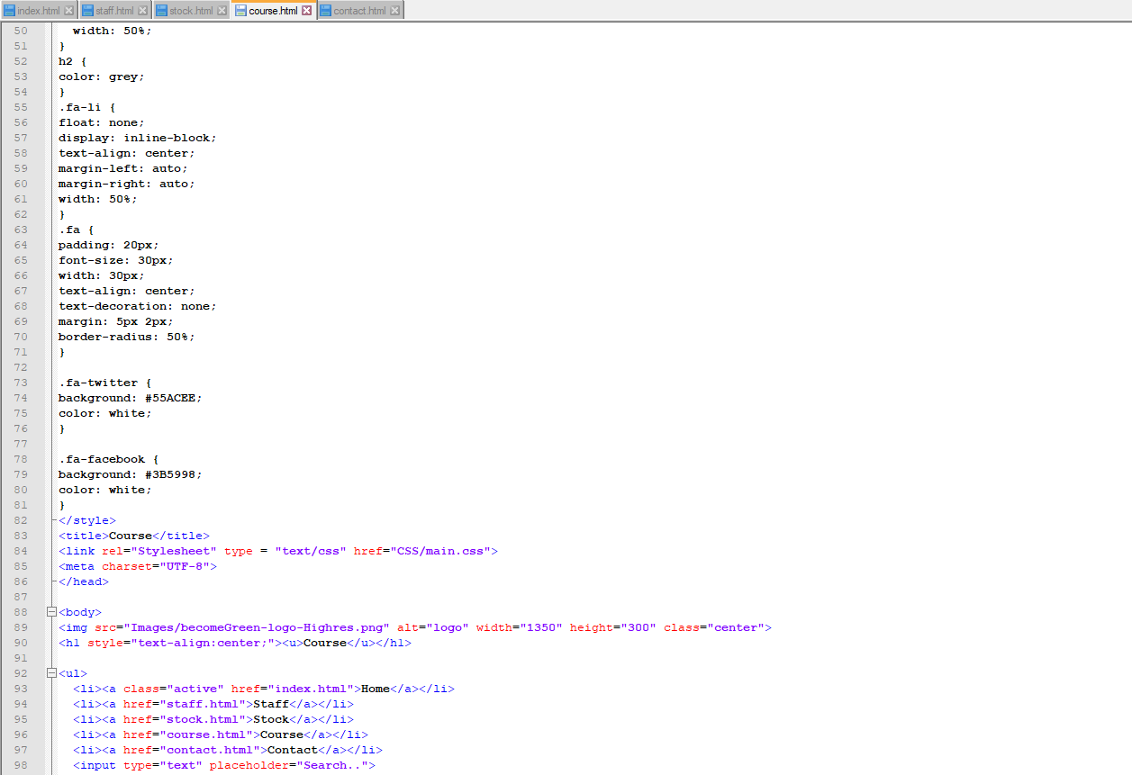

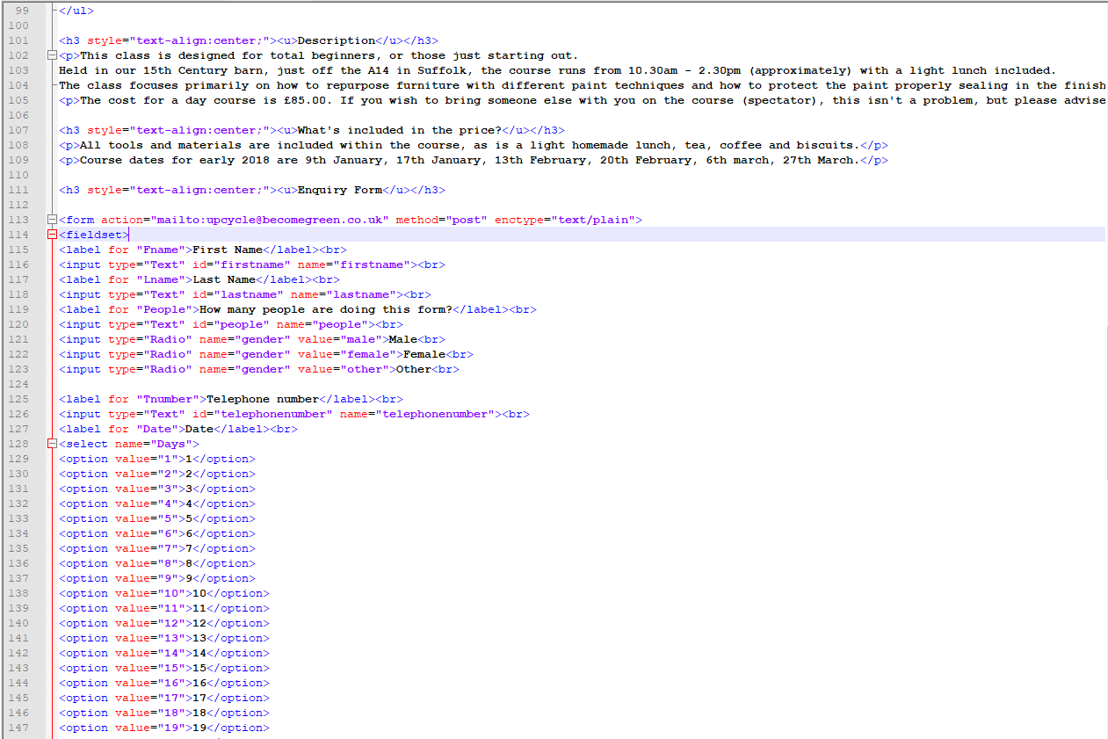

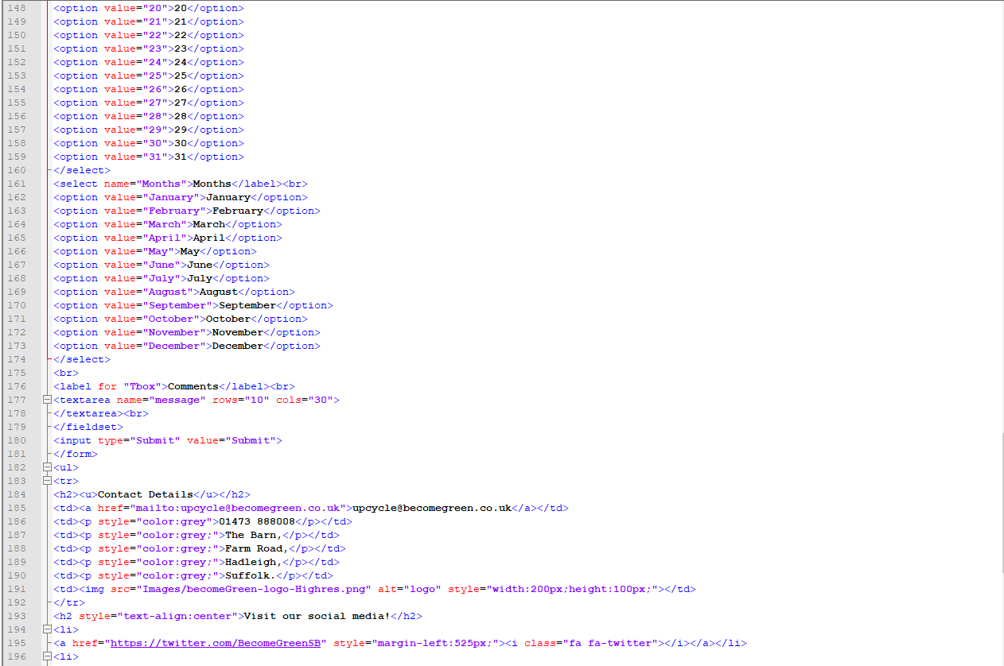

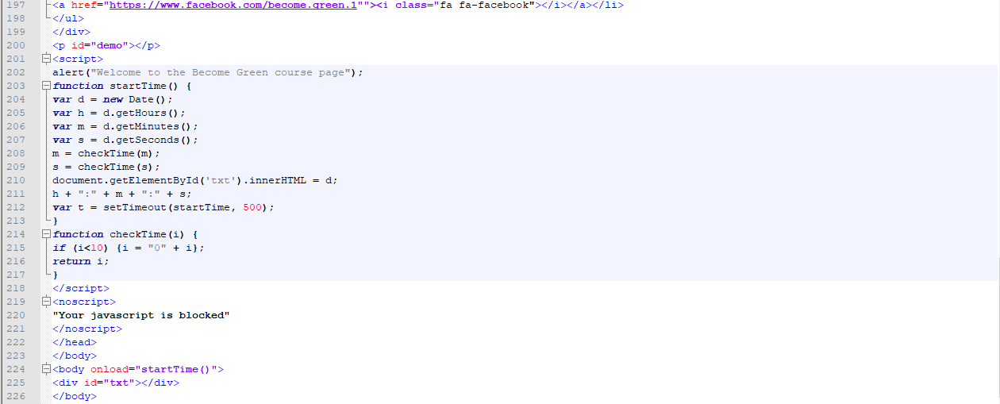

Figure : Course code

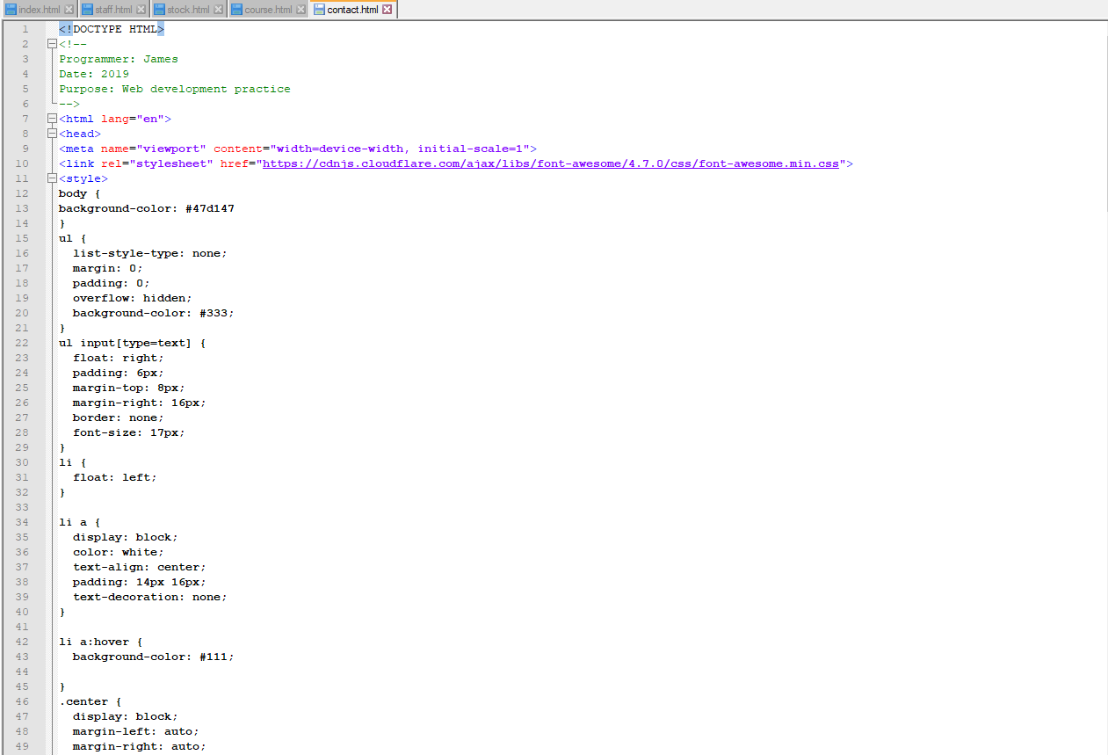

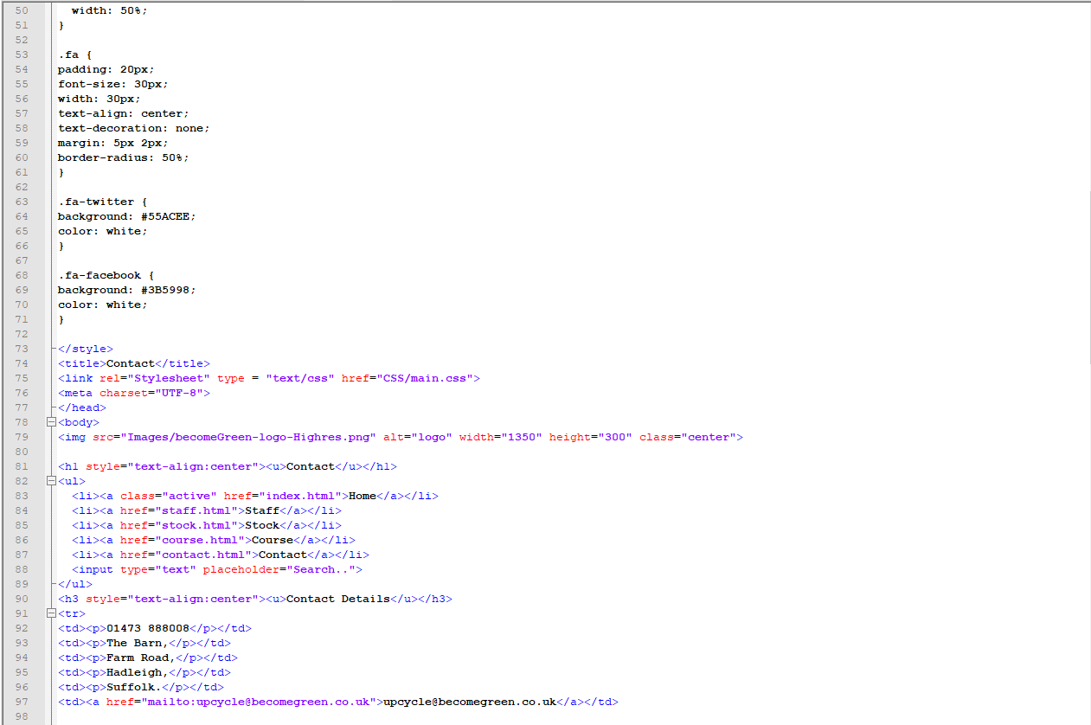

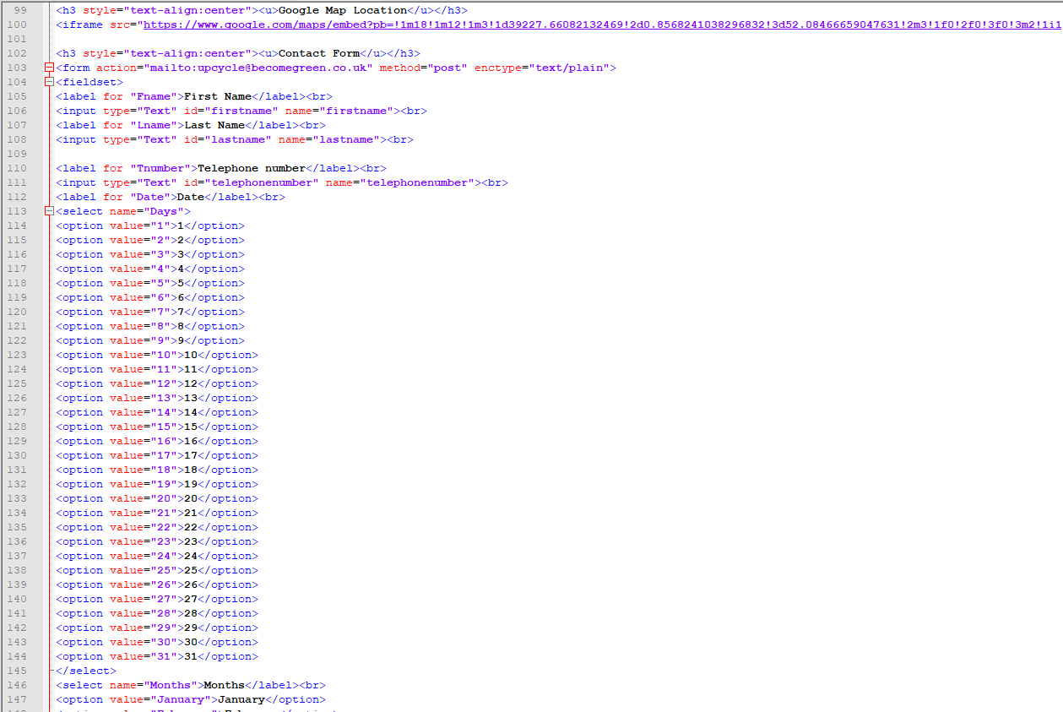

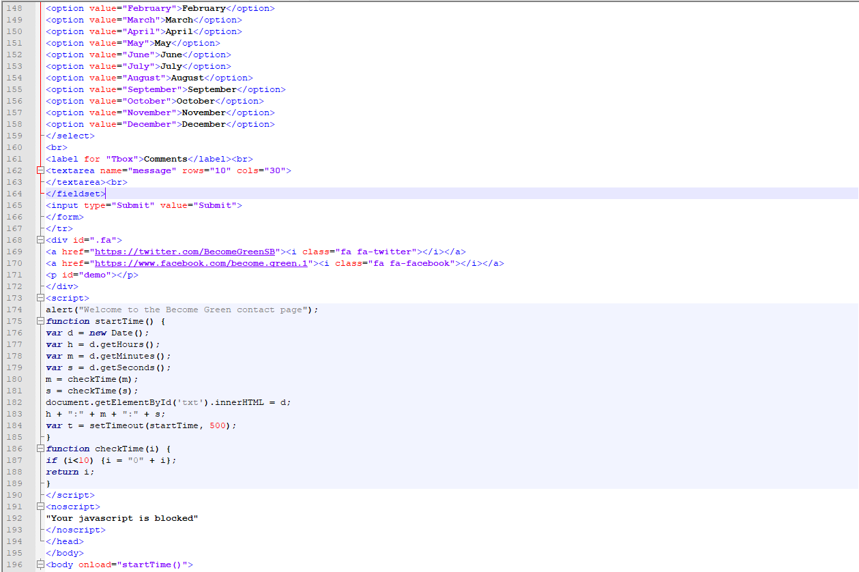



Figure : Contact code

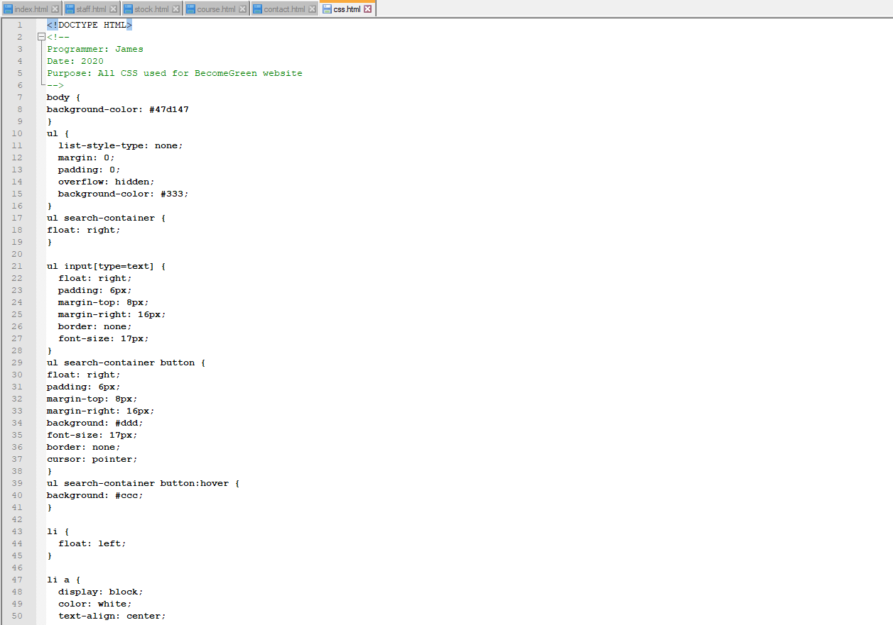

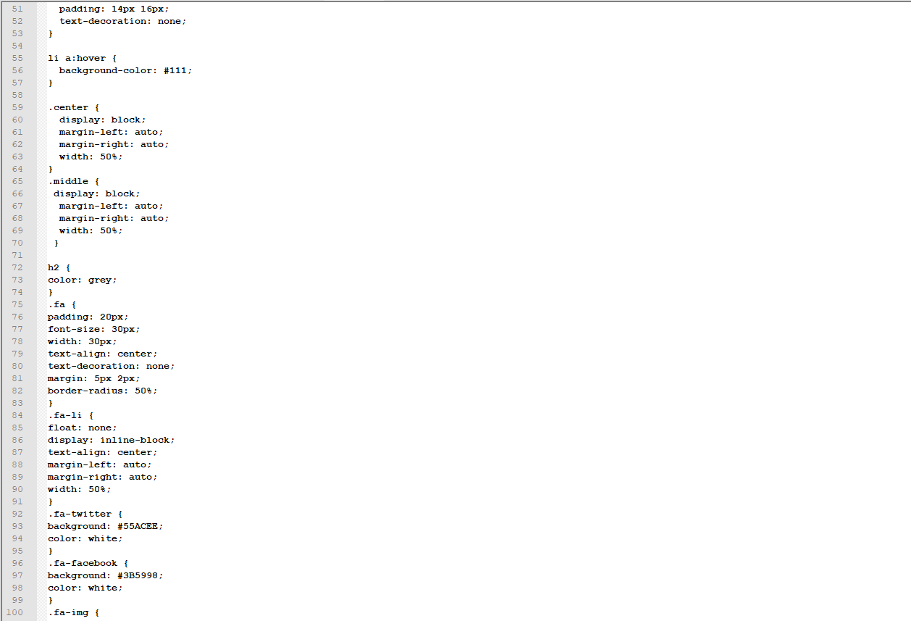

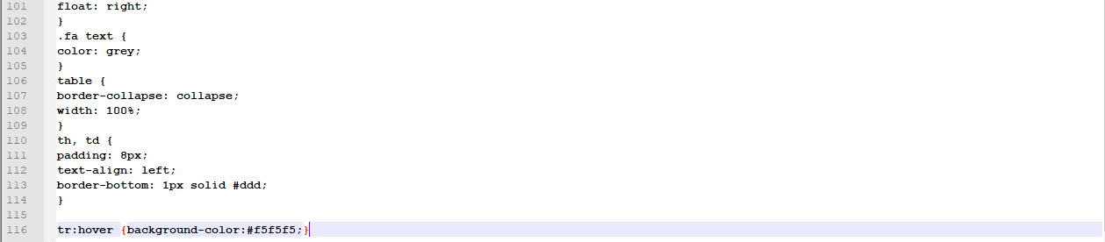

Figure : CSS document

# Appendix C – File Structure

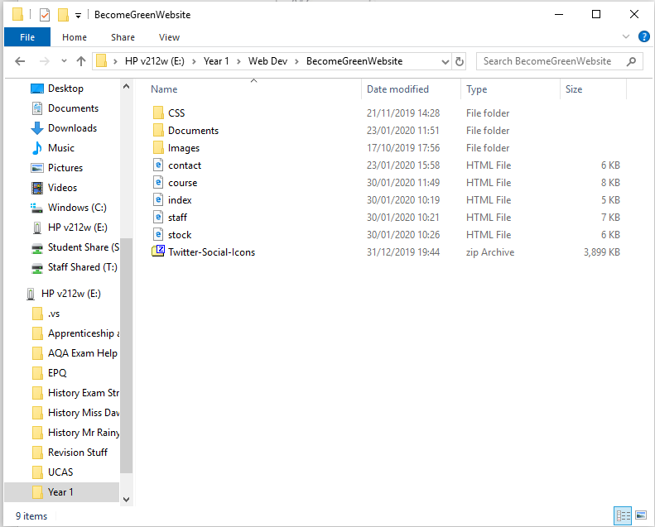

Figure : Final file structure